SUBCOURSE EDITION
OD0486 8

AGT 1500 C TURBINE ENGINE AND
PRINCIPLES OF THE COOLING
SYSTEM- M1 TANK



AGT 1500 C TURBINE ENGINE AND
PRINCIPLES OF THE COOLING SYSTEM - M1 TANK

SUBCOURSE OD0486
EDITION 8

United States Army Combined Arms Support Command
Fort Lee, VA 23801-1809

7 Credit Hours

NEW: 1988

GENERAL

The purpose of this subcourse is to introduce the M1 Abrams tank systems mechanic to the AGT 1500 C turbine engine and to the cooling system used on the M1 tank.

The scope of this subcourse broadly covers the construction, supporting systems, controls and monitoring devices on the AGT 1500 C turbine engine. In addition to the construction, supporting systems, and the control and monitoring devices on the engine, the cooling system on the M1 tank will also be discussed. We will cover the components and function of the M1 cooling system.

Seven credit hours are awarded for successful completion of this subcourse.

The passing score for ACCP material is 70%.

Lesson 1: CONSTRUCTION OF THE AGT 1500 C TURBINE ENGINE, SUPPORTING SYSTEMS, CONTROLS AND MONITORING DEVICES - M1 TANK

TASK 1: Describe the construction of the AGT 1500 C turbine engine.

TASK 2: Describe the supporting systems, controls, and monitoring devices of the AGT 1500 C turbine engine.

M1 ENGINE AND COOLING SYSTEM - OD0486

Lesson 2: PRINCIPLES OF THE COOLING SYSTEM - M1 TANK

TASK 1: Describe the components and function of the cooling system - M1 tank.

ii

M1 ENGINE AND COOLING SYSTEM - OD0486

TABLE OF CONTENTS

Section Page

TITLE i

TABLE OF CONTENTS iii

Lesson 1: CONSTRUCTION OF THE AGT 1500 C
TURBINE ENGINE, SUPPORTING
SYSTEMS, CONTROLS AND MONITORING
DEVICES - M1 TANK 1

Task 1: Describe the construction of the
AGT 1500 C turbine engine 1

Task 2: Describe the supporting systems,
controls, and monitoring devices of the AGT
1500 C turbine engine 38

Practical Exercise 1 51

Answers to Practical Exercise 1 53

Lesson 2: PRINCIPLES OF THE COOLING SYSTEM -
M1 TANK 55

Task 1: Describe the components and
function of the cooling system - M1 tank 55

Practical Exercise 2 59

Answers to Practical Exercise 2 60

REFERENCES 61

iii

M1 ENGINE AND COOLING SYSTEM - OD0486 - LESSON 1/TASK 1

LESSON 1

CONSTRUCTION OF THE AGT 1500 C TURBINE
ENGINE, SUPPORTING SYSTEMS, CONTROLS
AND MONITORING DEVICES - M1 TANK

TASK 1. Describe the construction of the AGT 1500 C turbine engine.

CONDITIONS

Within a self-study environment and given the subcourse text, without assistance.

STANDARDS

Within 3 hours

REFERENCES

No supplementary references are needed for this task.

1. Introduction

The M1 Abrams tank is capable of crossing great distances at high speeds. It is able to maintain these high speeds because of its engine. The M1 uses an automotive gas turbine (AGT) engine.

Gas turbines are internal combustion engines. They generate power by compressing a gas (air) that has been pumped into a suitable chamber, adding heat energy (by burning fuel), and expanding and expelling the heated gas through a nozzle, using rotating machinery that carries out the process in a steady flow. The gas that operates the turbine is the product of the combustion that takes place when a suitable fuel is mixed with the air passing through the engine. The gas turbine represents one of man's more ingenious means of harnessing energy. With the use of a few pounds of heat-resistant metal, properly shaped and in the presence of pressurized combustion gases, well supplied with heat, the gas turbine is capable of harnessing probably more mechanical shaft energy than any other man-made device of equal size and weight.

1

M1 ENGINE AND COOLING SYSTEM - OD0486 - LESSON 1/TASK 1

This task will cover the theory of operation of the AGT, the construction, i.e. the components of the AGT, and a comparison of the AGT with the piston engine.

2. Theory of Operation

In order to operate and maintain a modern turboshaft engine, such as the AGT 1500, it is necessary to understand the basic principles involved in its operation.

a. Mass. The first thing that must be realized is that all turboshaft engines attain their high rotational torque output, or power, from the energy transferred to the turbines by accelerated air mass within the engine. To better understand how this is accomplished, look at the simple containers shown in figure 1 (on the following page). Within the container (1) there are a certain amount of air molecules, the specific number of which can be referred to as density or volumetric density. It is this volumetric density, commonly referred to as mass, that is one of the key components required to drive turbines in the mass acceleration principle.

b. Pressure. A second component required in the acceleration principle is pressure, or the driving force. To attain this pressure, container number (2) is heated and the molecules contained expand and exert pressure equally in all directions. Having attained sufficient pressure within the container, the next step is to get the expanded mass to accelerate.

c. Accelerated Mass. To accomplish this, a convergent nozzle is added to container number (3). It is this convergency, or narrowing down of the nozzle area which causes the molecules to accelerate and produce the velocity energy required. It must be remembered that there is a tremendous amount of force in the velocity energy; as an example, water can be driven through concrete if it is going fast enough. Therefore, in order for us to take maximum advantage of this energy source, we must devise a way of converting velocity energy into useful rotational mechanical work.

2

M1 ENGINE AND COOLING SYSTEM - OD0486 - LESSON 1/TASK 1

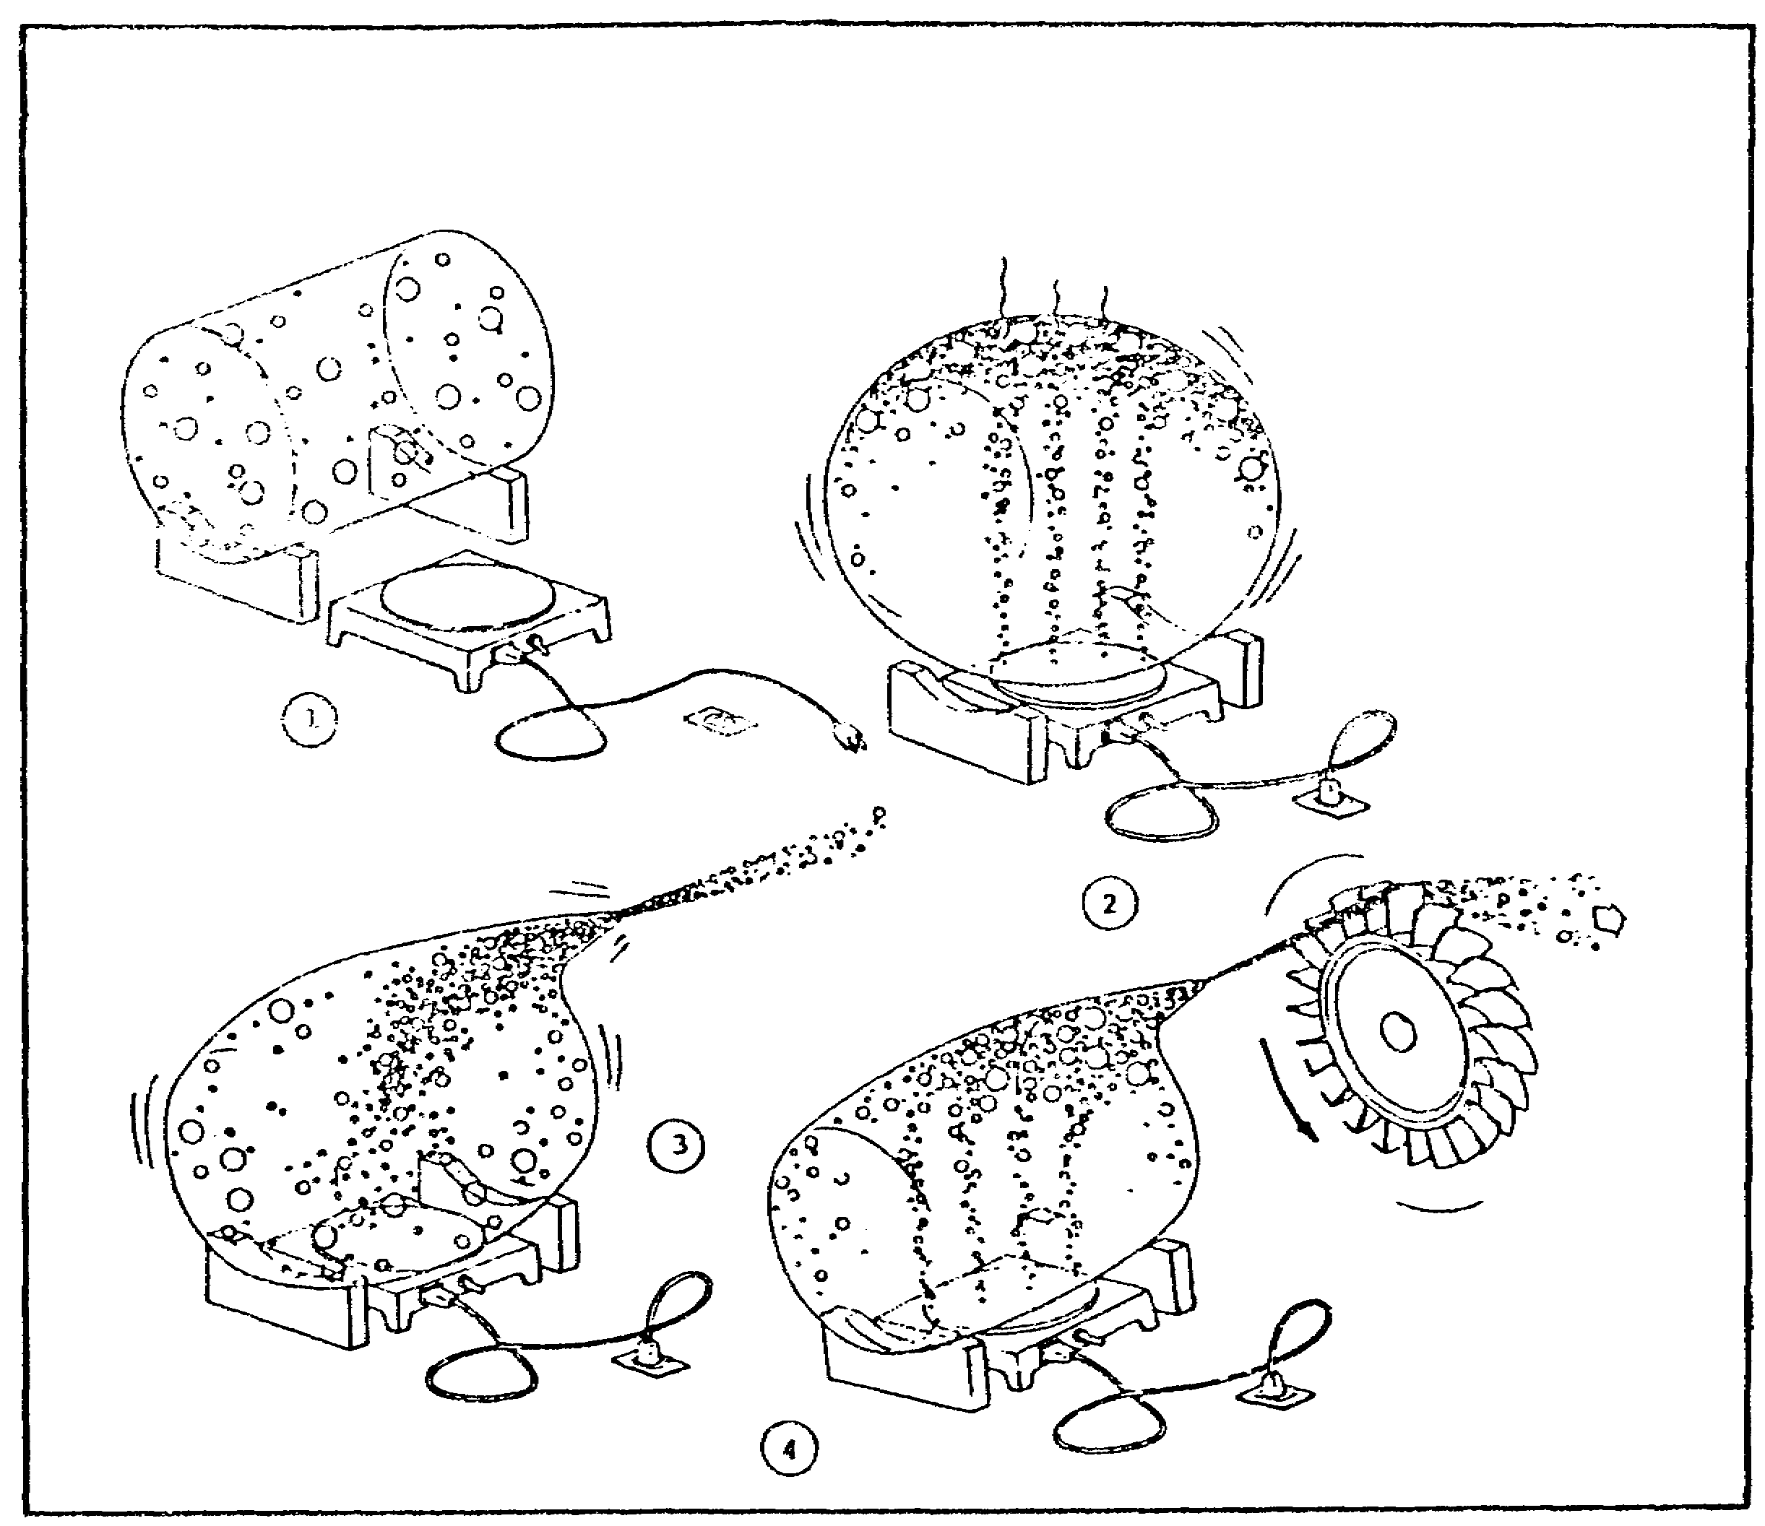

FIGURE 1. THEORY OF GAS TURBINE ENGINE OPERATION.

d. Conversion of Energy. This can be accomplished by adding an impact reaction type turbine wheel to container number (4). This particular type of turbine derives its name from the two forces it is subjected to in accomplishing the conversion of energy. The first force, as seen in the illustration, is the impact or push of the high velocity gases coming from the convergent nozzle and hitting the turbine wheel. The second force, which is a reaction force, is generated by the high velocity gases exiting the turbine wheel in the opposite direction to that of the rotation, as indicated by the arrow. This reaction force is a phenomenon that was discovered many years ago by Sir Isaac Newton when he was studying the physical properties of motion. One of the things that Newton discovered was that for every action upon a body, there is an equal and opposite reaction. If this principle is applied to the illustration, it

3

M1 ENGINE AND COOLING SYSTEM - OD0486 - LESSON 1/TASK 1

will be seen that the gases exiting the turbine wheel in one direction create an action which, in turn, produces a reaction in the opposite direction to drive the turbine.

As long as there is air in the container to expand and accelerate, this drive cycle will continue. However, since the container does not have a means of replenishing its air supply, the cycle will terminate in a very short period of time. Therefore, in order to make the cycle continuous, as it is in a modern turboshaft engine, it is necessary to modify the container by adding a mechanical compressor which will provide a continuous supply of air. This is accomplished by adding a combination axial-centrifugal compressor to provide all the high density air required to keep the cycle going. Since the driving force for the mechanical compressor is coming from the reaction turbine, the cycle will become continuous and self-sufficient, providing a continuous source of heat to expand the air is present.

e. Vehicular Power. As long as all the components just mentioned are present, the simple engine will function; however, it will not provide any useful work. Therefore, in order to get some useful work (or horsepower) out of this simple engine, it is necessary to make some additional changes. A second reaction type turbine has to be added, mounted on a shaft connected to a transmission, which in turn connects to the drive sprockets of a simple vehicle. Now, the velocity leaving the first turbine provides some useful work by driving the second turbine, which in turn drives the simple vehicle through the transmission and sprockets. Taking another look at the simple engine, the terminology gas producer turbine and power turbine becomes clear. The gas producer turbine being the first wheel, which drives the compressor to produce the air and gas needed, and the power turbine, which is obviously the second wheel, provides the power to drive the vehicles.

Remember, the starting point was a simple container of air, which was then heated and, with a convergent nozzle, accelerated and used to drive a turbine to produce useful work. However, if the simple engine is to be upgraded into a modern efficient power plant, such as the AGT 1500, some major modifications must be made and some additional components added.

4

M1 ENGINE AND COOLING SYSTEM - OD0486 - LESSON 1/TASK 1

First of all, in figure 2 (on the following page), all components are enclosed in a modern outer casing or housing. Next, a low pressure compressor (A), driven by a single stage turbine (B), and (C), a high pressure compressor driven by an additional single stage turbine (D) have been added. The combined efforts of both these compressors provide the air volume necessary for operation. Then, in order to attain an efficient heat source for the engine, the simple heater has been replaced by an efficient can-type combustor (I). To increase overall efficiency and reduce fuel consumption, the recuperator assembly (H) has been added. This simple device takes maximum advantage of the hot gases leaving the engine to heat the air mass entering the combustion area, thus reducing the overall amount of fuel required in combustion. To attain the useful work required from this prime mover, two additional turbines (E) have been added providing the mechanical drive to the reduction gear assembly (F) and the output shaft (G). Obviously, there are many other components in a modern turboshaft engine; however, for the purpose of understanding its basic operation it is not necessary to go into details of their operation. If the basic principles covered in this section are remembered, very little difficulty will be encountered in understanding the operation and maintenance requirements of the AGT 1500 system.

Figure 3 (on the following page) illustrates how the above description applies to a simplified block diagram of the engine.

3. Comparison of Reciprocating Engine to Turbine Engine

Figures 4 and 5, (on page 8) illustrate the operation first of the reciprocating, and second of the turbine engine. The cycle is similar, inasmuch as both engines must have an intake of air, a means of compression, an extraction of power, and a means of exhausting the gases after the energy has been extracted. This is where the similarity ends.

5
M1 ENGINE AND COOLING SYSTEM - OD0486 - LESSON 1/TASK 1

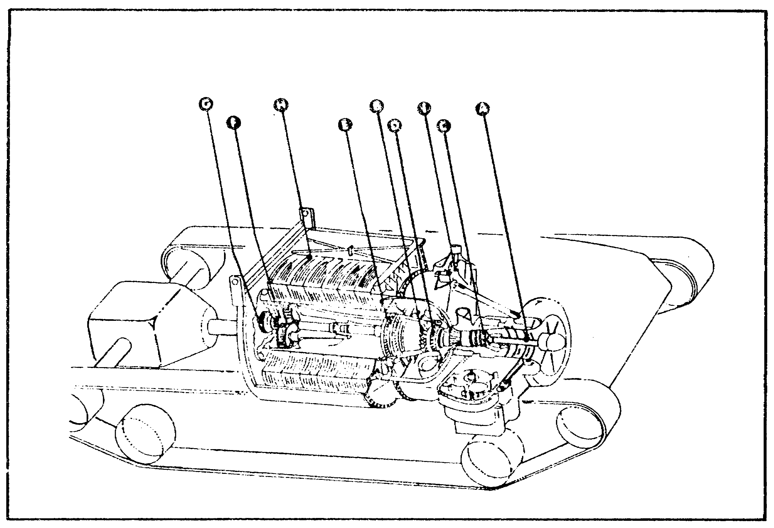

FIGURE 2. AGT 1500 VEHICULAR POWER.

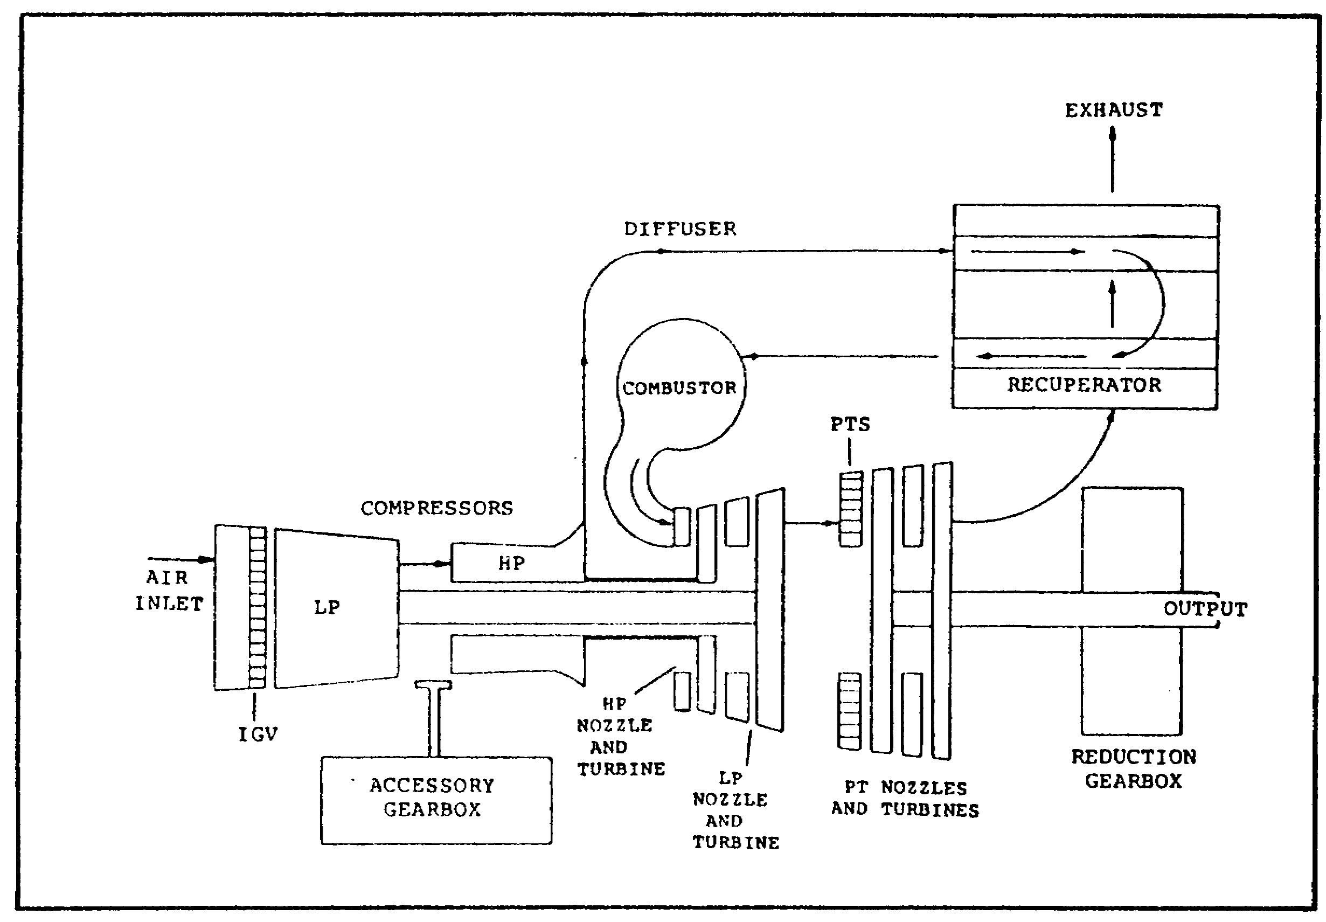

FIGURE 3. AGT 1500 BLOCK DIAGRAM.

6

M1 ENGINE AND COOLING SYSTEM - OD0486 - LESSON 1/TASK 1

a. Basic Reciprocating Engine Operating Cycle. The reciprocating (piston) engine performs four functions: intake, compression, power, and exhaust, within the realm of a closed cycle (Otto cycle)(figure 4). The intake event takes place with the downward movement of the piston within its cylinder. In this operation, the intake valve is open, allowing a fuel-air mixture to enter the cylinder. As the piston starts its upward movement the intake valve closes, allowing the piston to compress the mixture. When the piston reaches its peak of compression, the mixture is ignited and the expanding gases drive the piston downward (power event). The exhaust valve opens and the piston moves up in its cylinder, pushing the burned gases out to the atmosphere, completing one cycle.

b. Basic Gas Turbine Operating Cycle. Gas turbine engine operation consists of four events which are essentially the same as those of the reciprocating engine; however, these events are continuous. In the intake section of the Brayton cycle, figure 5, air is drawn through the air inlet section, passing through the compressor section for the compression event. The air then enters the combustor, mixes with the fuel and is ignited, expanding the gases and maintaining the pressure-volume which drives the turbines and extracts work, the power event. Passing through the turbines, the used gases are exhausted to the atmosphere (exhaust event).

4. Gas Turbine Engine Components Construction and Theory of Operation

a. General. The progression of gas turbine engine research and development has led to various designs of basic engine components. The operating characteristics, are presented in the following paragraphs to provide a background for presentation of the specific designs used by Avco Lycoming engines.

b. Compressors. There are three types of compressors; the axial compressor, centrifugal compressor, and the twin-spool compressor. Each of these will be discussed in the subparagraphs below. Common to all three is an air inlet section which serves to furnish a uniform and steady airflow to the face of the compressor. Inlet sections may be equipped with or without inlet guide vanes. Inlet

7

M1 ENGINE AND COOLING SYSTEM - OD0486 - LESSON 1/TASK 1

guide vanes serve to direct the air into the first stage of the compressor.

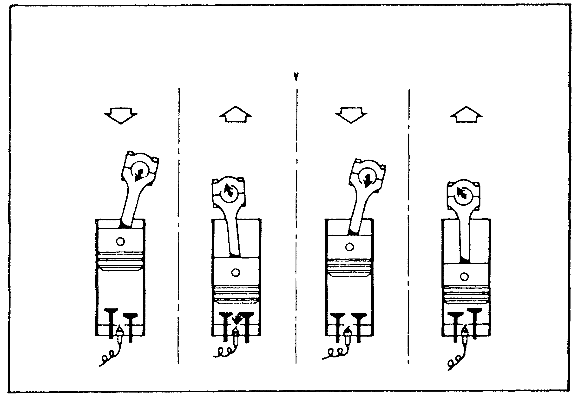

FIGURE 4. OTTO CYCLE.

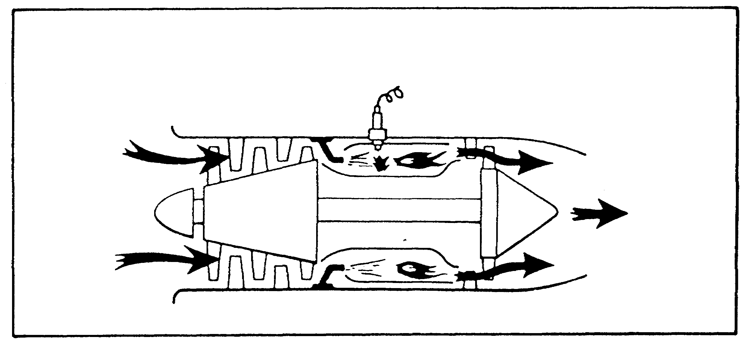

FIGURE 5. BRAYTON CYCLE.

(1) Axial Compressor. The air in an axial compressor flows in an axial direction through a series of rotating rotor blades and stationary

8

M1 ENGINE AND COOLING SYSTEM - OD0486 - LESSON 1/TASK 1

stator vanes which are concentric with the axis of rotation. The row of rotor blades and stator vanes is called a stage. Unlike the turbine, which also employs rotor blades and stator vanes, the flow path of an axial compressor decreases in cross-sectional area in the direction of flow in proportion to the reduced volume of the air as compression progresses from stage to stage. Figure 6 below, illustrates the rotor, stator vanes, and the compressor case of an axial compressor. Figure 7, on the following page, shows a cross-section of a typical axial compressor.

After being delivered to the face of the compressor by the air-inlet duct, the incoming air passes through a set of inlet guide vanes which direct the flow to the first-stage compressor rotor. Upon entering this set of rotating blades, the air, flowing in a general axial direction, is deflected in the direction of rotation. The air is arrested and turned by a set of stator vanes, picked up again by another set of rotating blades, and so on, from stage to stage, through the compressor.

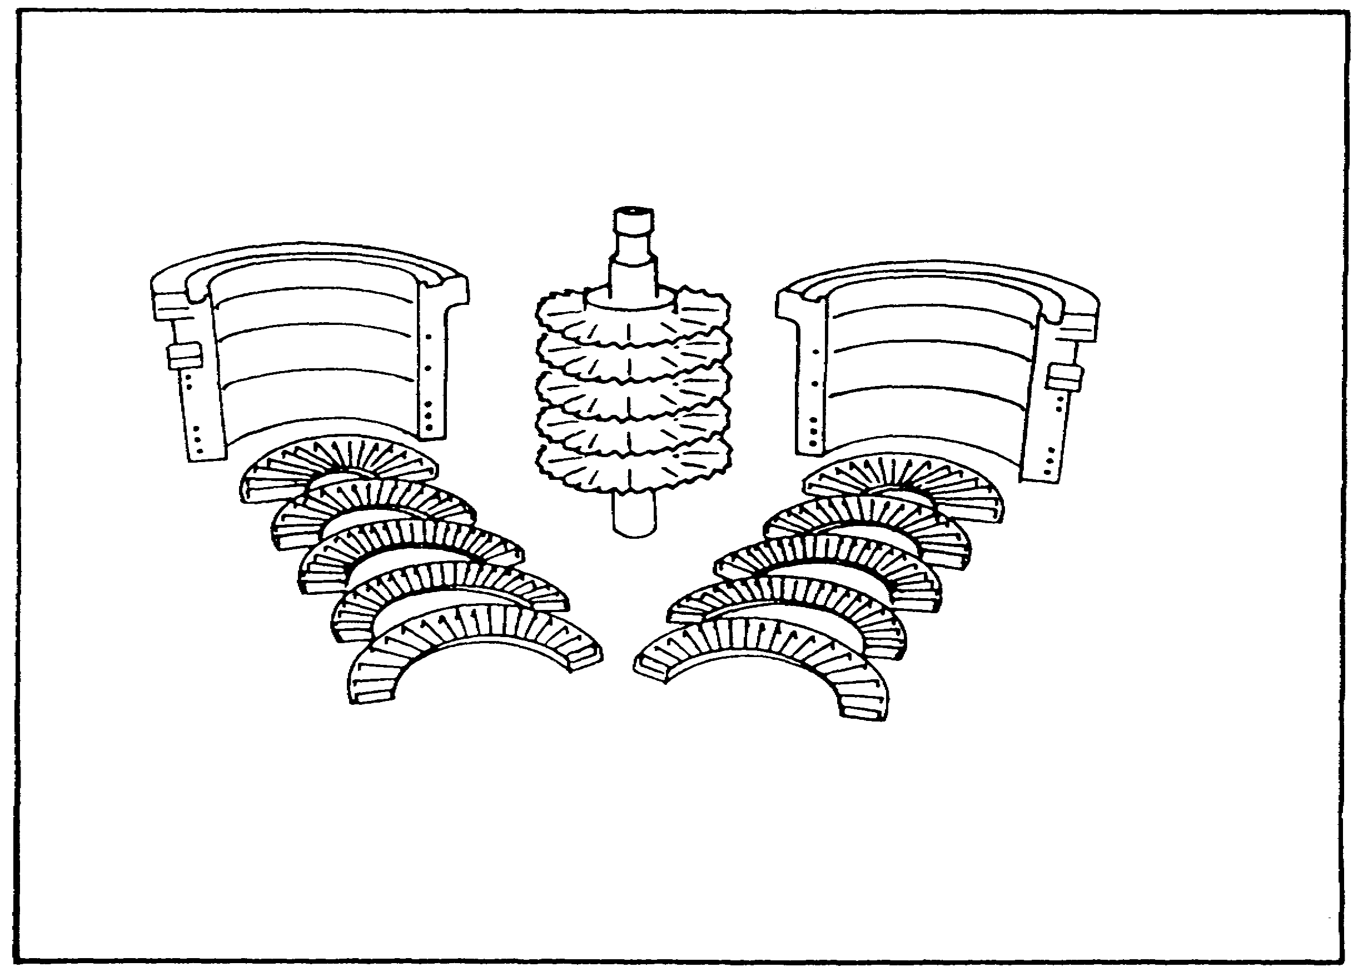

FIGURE 6. ROTOR, STATOR VANES, AND THE
COMPRESSOR CASE.

9

M1 ENGINE AND COOLING SYSTEM - OD0486 - LESSON 1/TASK 1

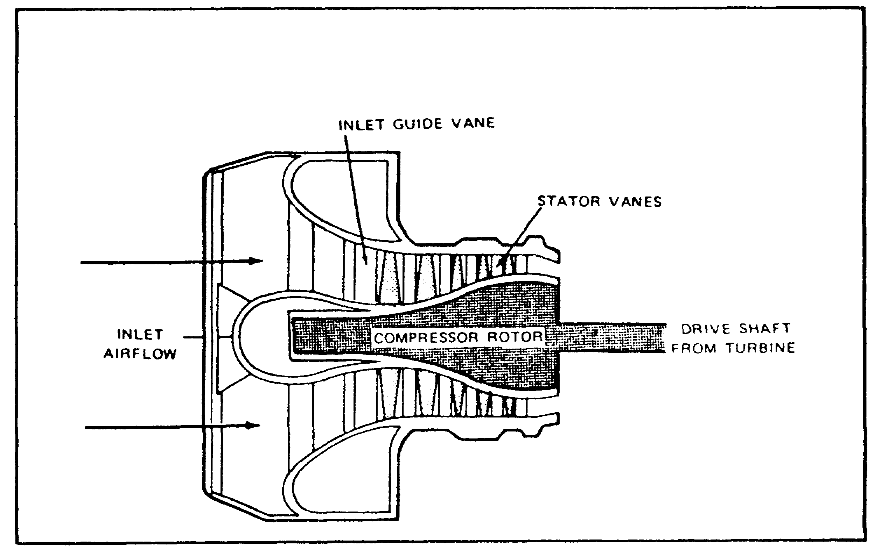

FIGURE 7. CROSS-SECTIONAL VIEW OF AN AXIAL
COMPRESSOR.

The pressure of the air increases as it passes through each successive set of rotors and stators. The rotors increase velocity while the stators decrease the velocity. The successive increases and decreases in velocity almost cancel each other, with the result that the velocity, as the air leaves the compressor, is usually only slightly greater than the velocity of the air at the inlet to the compressor.

As the pressure is built up by successive sets of rotors and stators, less and less volume is required. Thus, the volume within the compressor is gradually decreased. At the exit from the compressor, a diffuser section within the engine adds the final touch to the compression process by again decreasing the velocity, and increasing the static pressure, just before the air enters the engine burner section.

Axial compressors achieve efficiency ratings of 79 to 84 percent and compression ratios of from 5 to 1 up to 7 to 1.

(2) Centrifugal Compressors. This type of compressor consists of two main parts: an impeller and a diffuser (figure 8, on page 12).

10

M1 ENGINE AND COOLING SYSTEM - OD0486 - LESSON 1/TASK 1

Centrifugal compressors operate by taking in air near the hub of the impeller and accelerating it outward by centrifugal action. The impeller vanes (figure 9, on the following page) guide the air toward the outer circumference of the compressor, building up the velocity by means of the high rotational speed of the impeller. Air leaves the impeller at high speed and flows through a set of diffuser vanes which decelerate the air flow, converting high-velocity air to high-pressure energy. The diffuser vanes also serve to straighten the airflow.

In the AGT 1500, the diffuser section directs the air into the recuperator at an angle designed to retain a maximum of the energy imparted by the impeller, and at a velocity and pressure which will be satisfactory for use in the combustor section of the engine. Centrifugal compressors achieve efficiency ratings of 78 to 84 percent, and compression ratios of from 3 to 1 to 5 to 1.

(3) Twin-Spool Compressors. Another type of axial compressor is the dual rotor, or twin-spool compressor. Greater flexibility for part-throttle conditions and for starting can be attained more efficiently by splitting the compressor into two mechanically independent rotor systems. Each is driven at its own best speed by its own separate turbine.

Usually the rear, or high pressure, compressor rotor is "speed governed" by the engine fuel control, and is the rotor to which the engine starter is connected. With the rear, high pressure, compressor turning at the governed speed, the front, or low pressure, compressor (which is not governed) is automatically rotated by its turbine at whatever speed will ensure the optimum flow of air through the compressor. The low and high pressure rotors of the compressor individually adjust their revolutions per minute (rpm) when necessary, during part-throttle operation, to prevent compressor stall with a minimum of required interstage bleeding.

11

M1 ENGINE AND COOLING SYSTEM - OD0486 - LESSON 1/TASK 1

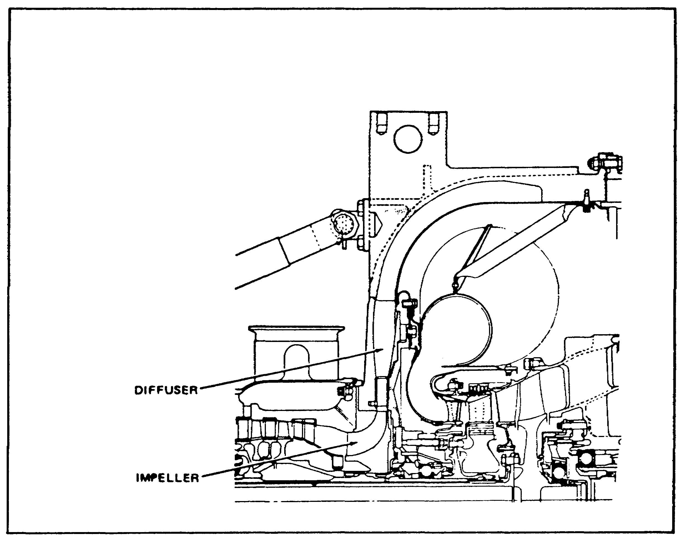

FIGURE 8. CROSS-SECTION OF A CENTRIFUGAL
COMPRESSOR.

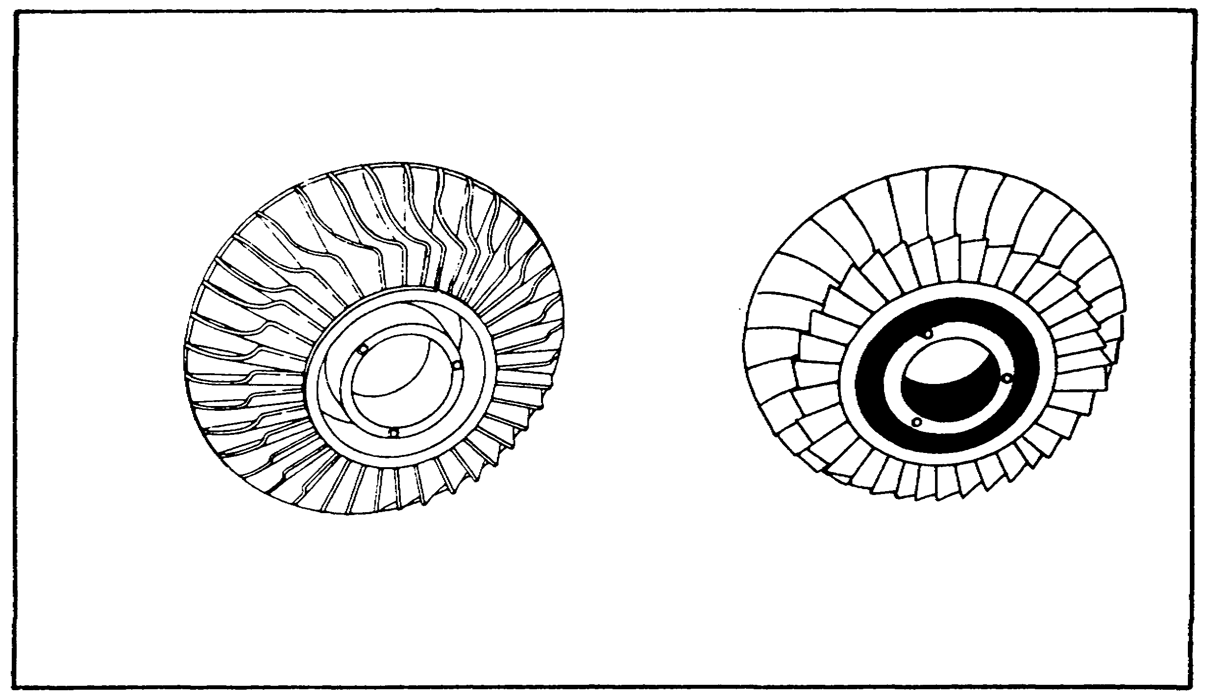

FIGURE 9. IMPELLER VANES.

12

M1 ENGINE AND COOLING SYSTEM - OD0486 - LESSON 1/TASK 1

Twin-spool compressors operate with an efficiency rating of approximately 85 percent. Figure 10 shows the twin-spool design concept of the AGT 1500. Note that a centrifugal stage has been added to the high pressure rotor to increase efficiency and shorten engine length. This particular design achieves a compression ratio of 14.5 to 1.

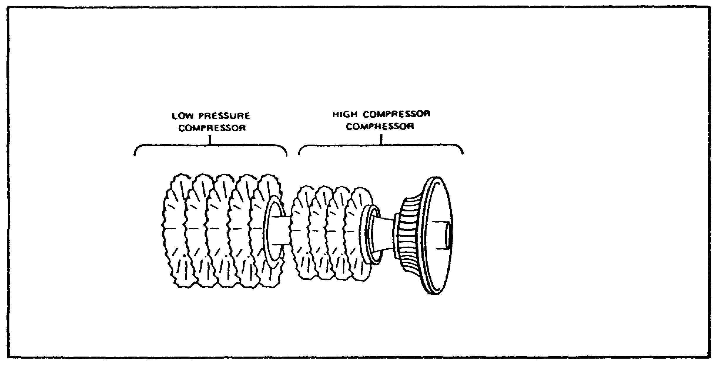

FIGURE 10. TWIN-SPOOL COMPRESSOR.

c. Combustion Chamber. The combustion chamber is designed to burn a mixture of fuel and air, and to deliver the resulting gases to the turbine at a temperature which will not exceed the allowable limits at the turbine inlet. The chamber, within a very limited space, must add sufficient heat energy to the gases passing through the engine to accelerate their mass efficiently to produce the desired power for the turbine section.

Combustion chambers are built in a number of different designs. The design is such that less than a third of the total volume of air entering the chamber is permitted to mix with the fuel. The remaining air is used downstream to cool the combustor surfaces and to mix with and cool the burned gases before they enter the turbines.

The combustion chamber, shown in figure 11 on page 15, is the type used in the AGT 1500. It is a single can combustor which leads into a distribution scroll that channels the combustor gases uniformly to the first-stage turbine nozzle.

13

M1 ENGINE AND COOLING SYSTEM - OD0486 - LESSON 1/TASK 1

This type of burner has excellent serviceability. The liner may be removed from the engine for inspection or replacement without disturbing the engine installation.

Atomized fuel is introduced through a fuel nozzle located in the center of the swirl cup. Louvers in the swirl cup create the mixing vortex into which the fuel is sprayed. The air admission pattern in the primary zone is such that a high degree of fuel-air mixing occurs within the zone.

In the intermediate and diluent zones of the liner, the hot combustion gases emanating from the primary zone are cooled with air so that the combustion chamber exit temperature profile is compatible with the turbine inlet temperature requirements. Secondary air slots permit this film of cooling air to be introduced along the inner surfaces of the flame exposed areas. This cooling film also protects the metal from carbon, fuel residue deposits and oxidation.

d. Turbines. The turbine extracts kinetic energy from the expanding gases which flow from the combustion chamber, converting it into shaft horsepower to drive the compressor and engine accessories. Most of the energy available from the products of combustion is necessary to drive the compressor, or compressors in the case of the dual compressor engine. Additional power turbines may be employed to provide vehicular power.

(1) Turbine Theory and Design. The axial-flow turbine is comprised of two main elements: a turbine wheel or rotor and a set of stationary vanes. The stationary section consists of a plane of contoured vanes, concentric with the axis of the turbine, and set at an angle to form a series of small nozzles which discharge the gases onto the blades of the turbine wheel. For this reason, the stationary-vane assembly is usually referred to as the turbine nozzle and the vanes are called nozzle vanes. The turbine nozzle area is a critical part of the turbine design; if it is too large or too small, the turbine will not operate at its best efficiency.

14

M1 ENGINE AND COOLING SYSTEM - OD0486 - LESSON 1/TASK 1

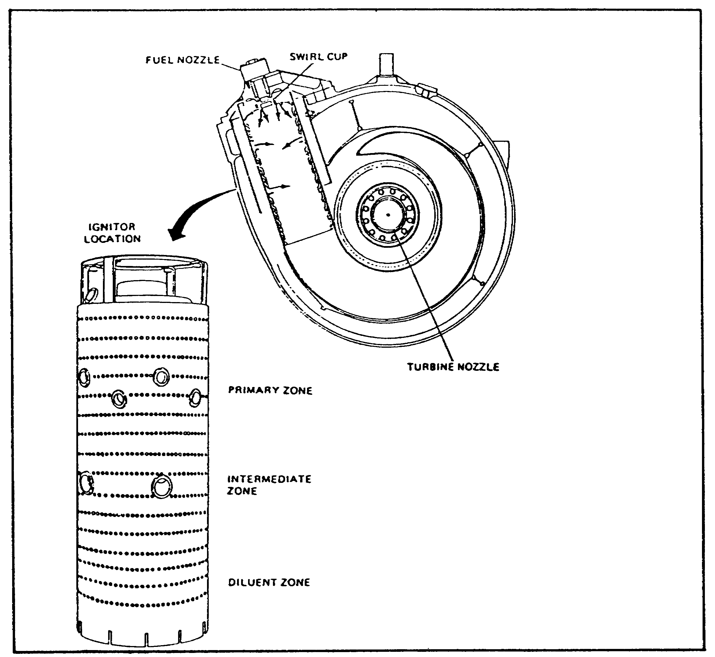
FIGURE 11. COMBUSTION CHAMBER.

From the cross-section diagram of a turbine nozzle in figure 12 on the following page, we see that the nozzle's function is to accomplish two separate tasks. The first is to accelerate the gases by means of the convergent shape of the passage, the second is to deflect the gases to a specific angle, in the direction of the turbine wheel rotation.

Turbines are divided into three types: impulse, reaction, and a combination of these two, known as impulse-reaction, which is in more common use today (figure 13, on the following page).

15

M1 ENGINE AND COOLING SYSTEM - OD0486 - LESSON 1/TASK 1

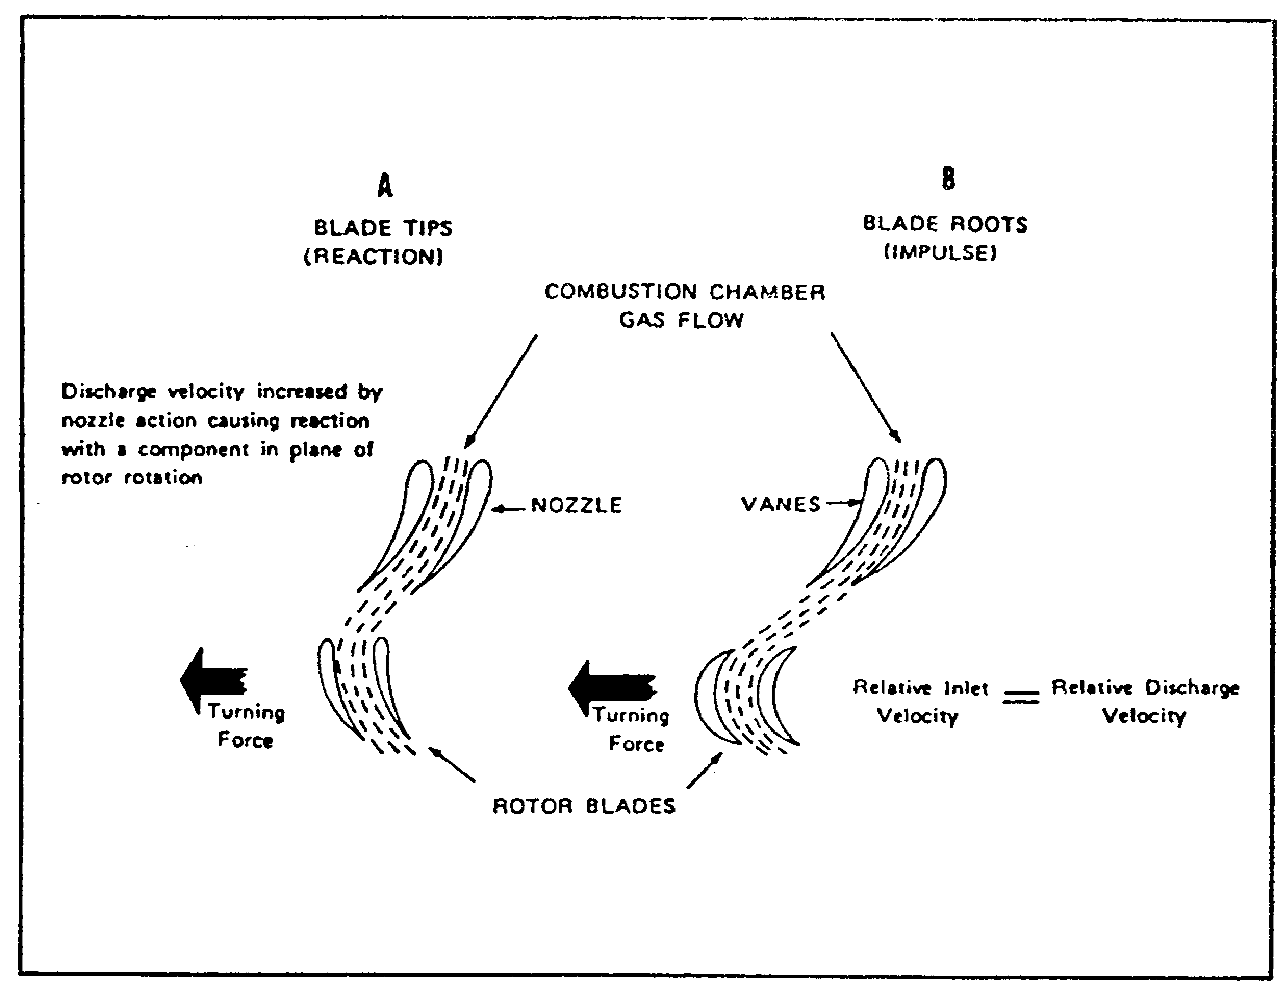

FIGURE 12. CROSS-SECTION OF THE TURBINE NOZZLES.

In the impulse type, B in figure 12, there is no net change in the pressure between the rotor inlet and the rotor exit. Thus, the blade's relative discharge velocity will be the same as its relative inlet velocity. The nozzle vanes are shaped to form passages which increase the velocity and reduce the pressure of the escaping gases.

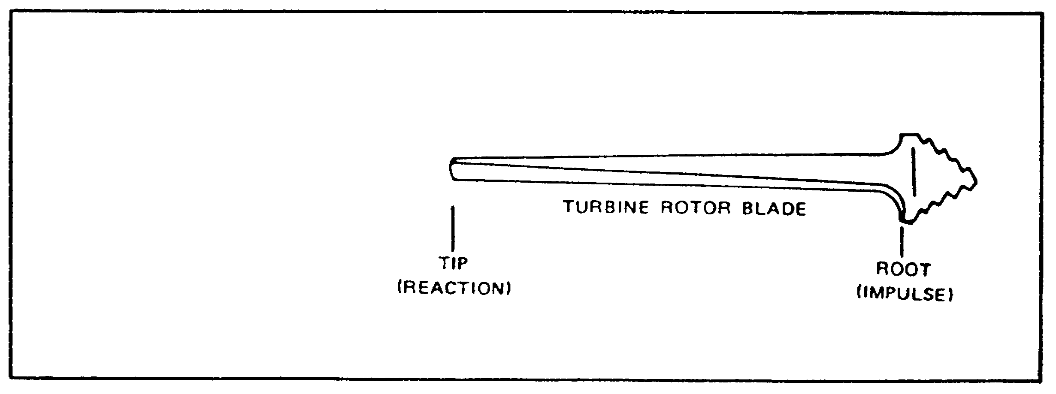
FIGURE 13. IMPULSE-REACTION TURBINE ROTOR BLADE.

16

M1 ENGINE AND COOLING SYSTEM - OD0486 - LESSON 1/TASK 1

In the reaction type, A in figure 12, the nozzle vanes do little else in relation to the rotor than alter the direction of the flow. The decrease in the pressure and increase in the velocity is accomplished by the convergent shape of the passage between the rotor blades.

The impulse-reaction turbine, which is the third type to be discussed, is a combination of the impulse and reaction design. The larger circumference of the assembly at the ends of the turbine blades requires the tips to travel at a faster rate of speed than the roots to obtain the same degree of rotation. The impulse-reaction type blade uses this concept to equalize the velocities of the gases exiting the root and tip of the turbine wheel. This type is designed so that the base of the blade is an impulse design and the tip is a reaction design. This provides an equal pressure distribution across the blade and, therefore, an efficient turbine blade. The impulse-reaction turbine is used almost exclusively in modern turboshaft engines.

(2) Turbine Rotors and Blades. Turbines may be either single or multistage (figure 14, on the following page). When the turbine has more than one stage, stationary vanes are inserted forward of each rotor wheel. Each set of stationary vanes forms a nozzle-vane assembly for the succeeding turbine wheel. Later in this subcourse, we will discuss how the AGT 1500 employs a variable nozzle-vane assembly. The wheels may or may not operate independently of one another, depending upon the type of engine and the power requirements of the turbine.

The turbines shown in figure 14, on the following page, are of the type and configuration required to drive the AGT 1500 twin-spool compressor. The low pressure compressor drive shaft runs through the hollow center of the high compressor drive shaft, thereby allowing these two systems to operate independently. The two-stage power turbine also operates independently of the compressor turbine system and, in this case, is shafted rearward for power output.

Note how the turbine diameters and blade areas increase in size with each succeeding stage. The turbine which drives the high pressure compressor receives gases of high energy directly from the

17

M1 ENGINE AND COOLING SYSTEM - OD0486 - LESSON 1/TASK 1

combustor and turns at a higher rpm than the turbine for the low pressure compressor. By the time the gases reach the rear part of the turbine, which drives the low pressure compressor, they have been expanded by passing through the forward part of the turbine. Therefore, considerably more blade area is needed if proper work or energy balance is to be maintained. To be capable of supplying sufficient power for the compressor and power output sections, the turbine must be designed so that the gases have a high expansion ratio.

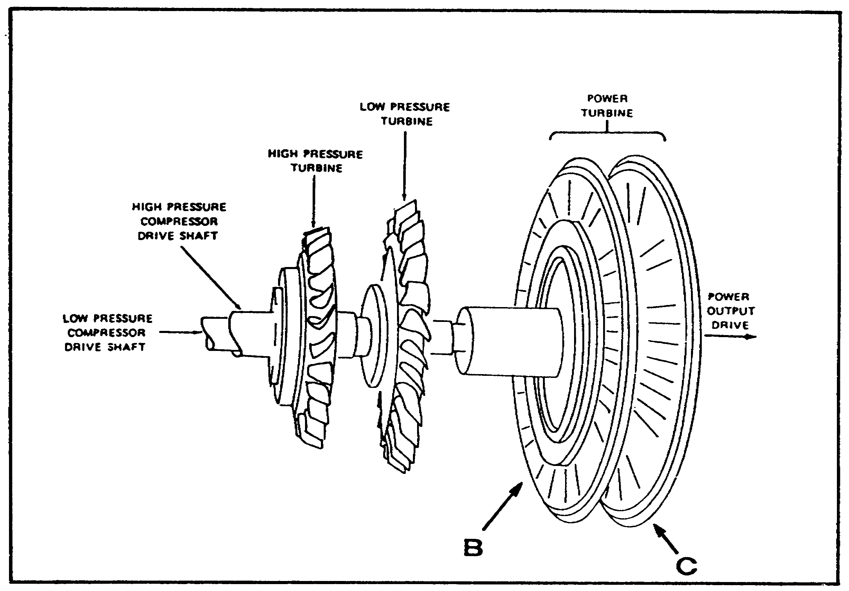

FIGURE 14. MULTISTAGE TURBINE.

The turbine wheel is a dynamically balanced unit consisting of steel alloy blades, attached to a rotating disc (B and C, figure 15, on the following page). The base of the blade at the turbine inlet (B) is usually of a so-called "fir tree" design to enable it to be firmly attached to the disc and still allow room for expansion. The remaining turbine wheels and blades are usually integrally casted.

18

M1 ENGINE AND COOLING SYSTEM - OD0486 - LESSON 1/TASK 1

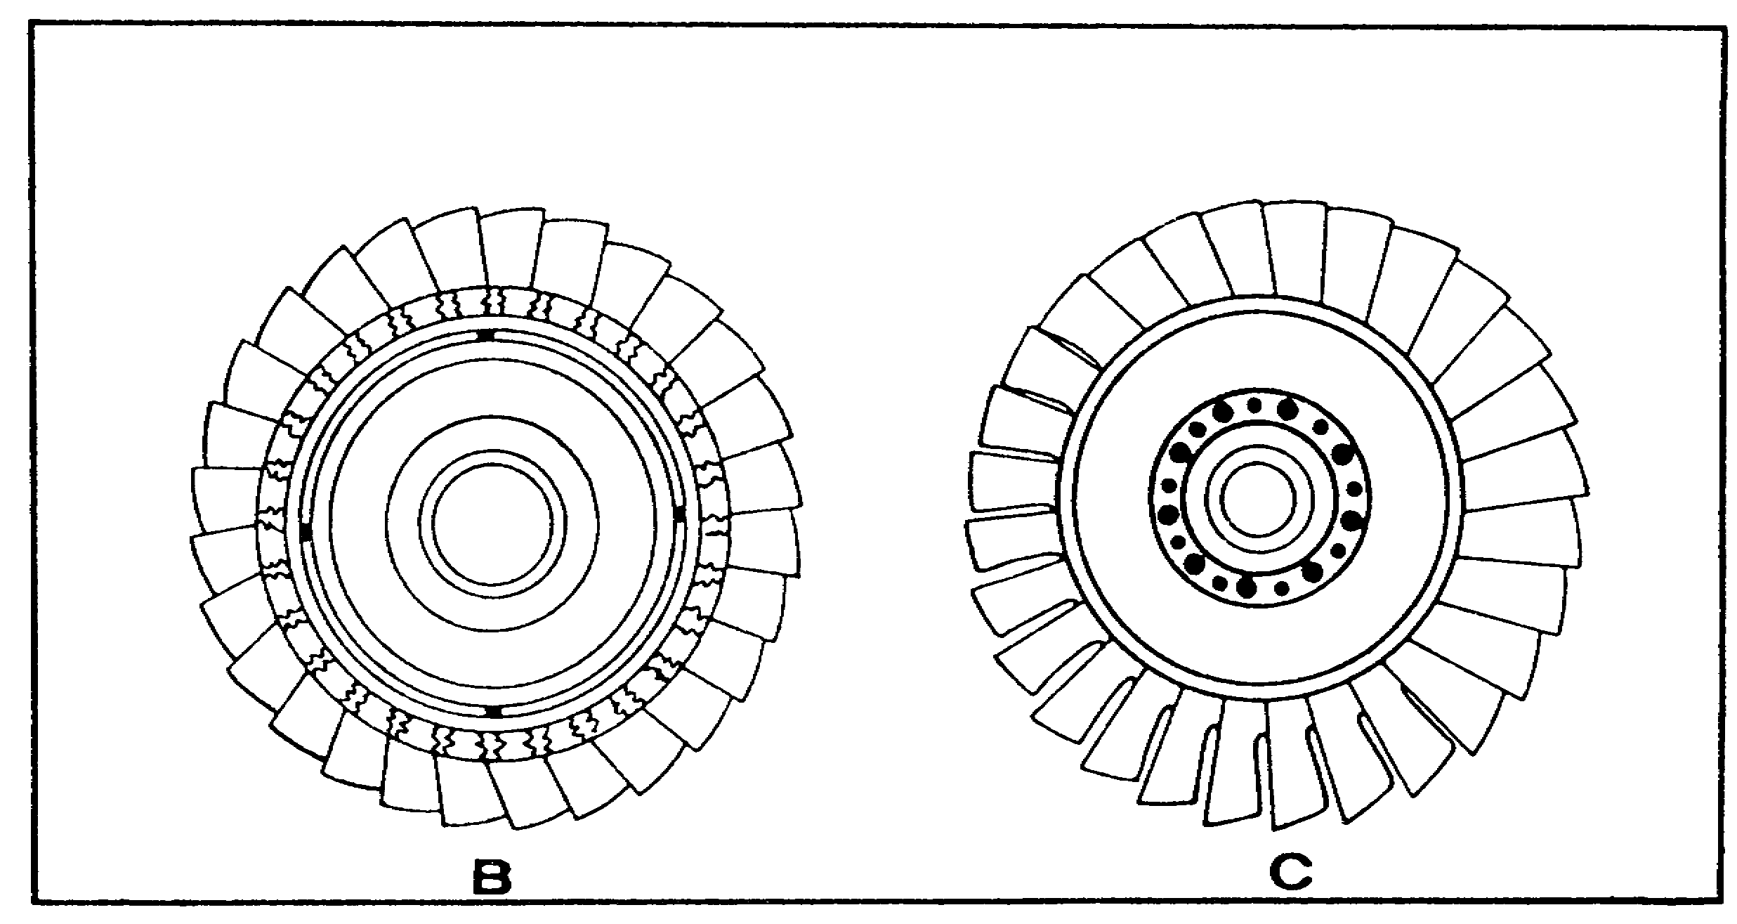

FIGURE 15. TURBINE ROTORS AND BLADES.

Turbines are subjected to both high speeds and high temperatures which, if exceeded, will lower the strength of the construction materials used in turbines. Internal cooling of the nozzle vanes and turbine blades is necessary only in the area of the turbine inlet, because enough energy is subsequently extracted from the exhaust gases by the first-stage to reduce the temperature to a tolerable level.

5. AGT 1500 Description and Operation

The AGT 1500 turbine engine is a free-power turbine engine using a twin-spool compressor and a counterflow-type recuperator. Basically, the engine is comprised of an air inlet section, a low pressure compressor section, a high pressure compressor section, an accessory gearbox, a combustor, a high pressure turbine section, a low pressure turbine section, a power turbine section, a recuperator section, a reduction gear section, a power output shaft, and a fuel management system consisting of a hydromechanical unit and an electronic control unit. The engine is equipped with a lubricating oil reservoir. Provision is made for mounting and driving an auxiliary power take-off for a hydraulic pump, oil pump, a hydromechanical unit, and for the mounting of a starter. Integral electrical harnesses provide circuitry for engine controls and instrumentation.

19

M1 ENGINE AND COOLING SYSTEM - OD0486 - LESSON 1/TASK 1

a. General Description. The AGT 1500 turbine engine weighs less than 2500 pounds. The engine is approximately 67 inches long, 39 inches wide, and 30 inches high. The engine is capable of producing 1500 shaft horsepower (shp) at a power setting of 100% up to 87 degrees Fahrenheit. In addition the engine produces 3000 rpm output shaft speed at a 100% power setting. The engine uses either DF-2, DF-1, DF-A (VV-F-800), JP-4, or JP-5 as the primary fuels. However, in an emergency combat gasoline (MIL-6-3056) and marine diesel (MIL-F-16884) may be used as fuel. Though the M1 tank has three fuel tanks, the right front, left front, and rear, the fuel is fed to the engine from the rear tank only.

CAUTION

Continued use of emergency fuels may result in permanent engine performance degradation and hardware damage.

The engine uses MIL-L-23699 or MIL-L-7808 as lubricating oils. The oil tank has a capacity of 17 quarts. However, if the oil tank and the accessory gearbox are both to be filled it will require 26 quarts of oil. The engine has an ambient temperature operating range of -65 degrees to +125 degrees Fahrenheit.

b. Modular Construction. The engine is comprised of three major modules (figure 16, on the next page):

o Forward module (2)

o Rear module (including reduction gearbox submodule)(3)

o Accessory gearbox module (1)

Each module is a replaceable unit, so that the entire engine need not be overhauled if damage occurs in any single module.

(1) Module Interface. The forward module and the rear module are bolted together by a bolt flange at the recuperator header and the air diffuser/support housing assembly split line (B, figure 16). The accessory gearbox is attached to the forward module by two pins that hold the gearbox to the diffuser (A, figure 16). In addition, two bolts hold the gearbox to the low pressure compressor housing.

20

M1 ENGINE AND COOLING SYSTEM - OD0486 - LESSON 1/TASK 1

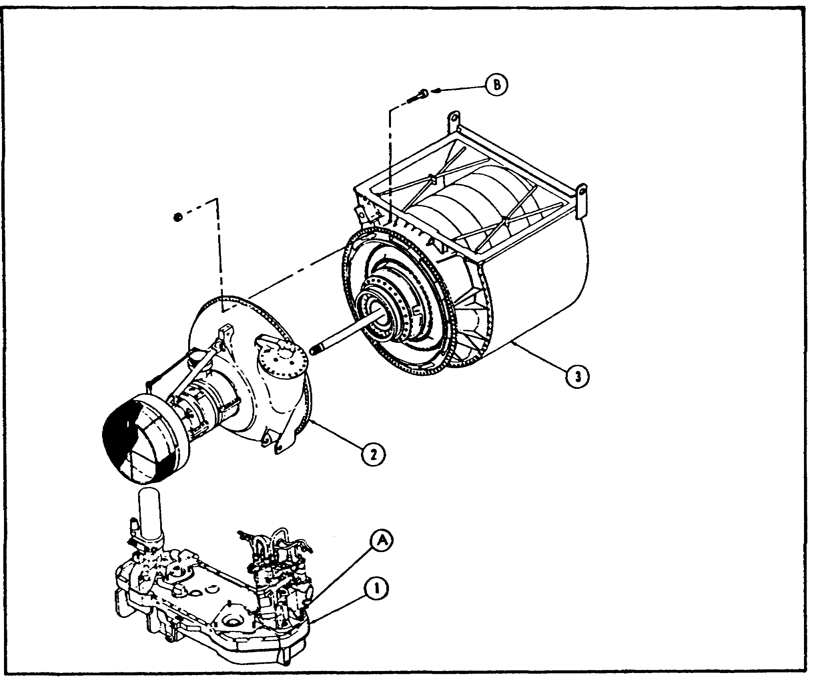

FIGURE 16. AGT 1500 MODULAR CONSTRUCTION.

c. Forward Module. The forward engine module consists of the inlet housing assembly (1, figure 17, on the next page), low pressure compressor assembly (2), midframe or intermediate housing assembly (3), high pressure compressor assembly (4), diffuser and combustor assembly (5), high pressure nozzle (6), and the plate and disc assembly (7).

(1) Inlet Housing Assembly. The inlet housing assembly consists of the outer bellmouth with support struts, and the splitter assembly. The inlet housing assembly is made of a stainless steel alloy.

(2) Low Pressure Compressor Assembly. The low pressure compressor assembly is a two-piece housing which contains the five stage axial compressor and stator vanes. The low pressure compressor assembly is also made of a stainless steel alloy.

21

M1 ENGINE AND COOLING SYSTEM - OD0486 - LESSON 1/TASK 1
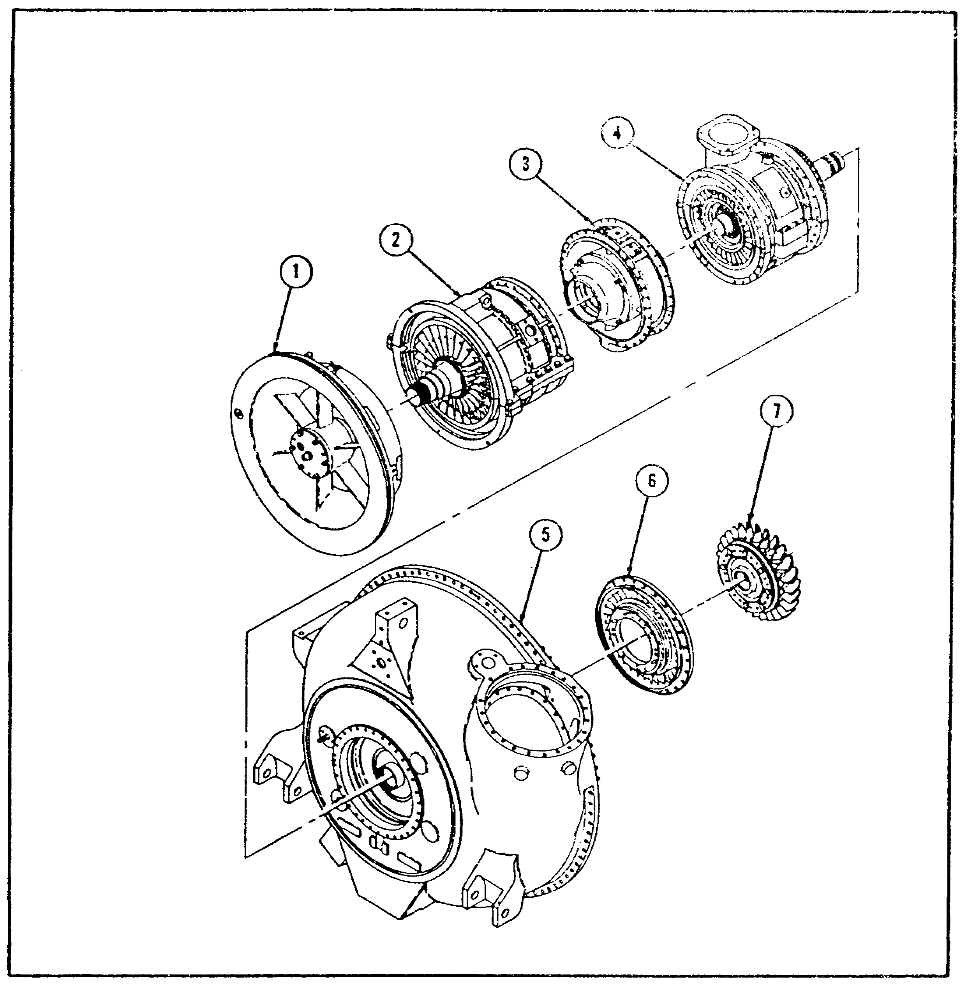

FIGURE 17. FORWARD ENGINE MODULE MAJOR COMPONENTS.

(3) Mid-Frame or Intermediate Housing Assembly. The intermediate housing assembly contains the compressor bearing support and the accessory bevel gear drive. Like the inlet housing and the low pressure compressor assemblies, the intermediate housing assembly is made of a stainless steel alloy.

(4) High Pressure Compressor Assembly. The high pressure compressor assembly is of two-piece construction, the inner and outer housings, which contain the four stage axial/centrifugal compressor and stator vanes. The high pressure compressor assembly is made of a stainless steel alloy.

22

M1 ENGINE AND COOLING SYSTEM - OD0486 - LESSON 1/TASK 1

(5) Air Diffuser Assembly. The air diffuser assembly provides the rear attaching point for the accessory gearbox. It contains the high pressure nozzle and turbine. The air diffuser assembly is made of a stainless steel alloy.

(6) Combustor Assembly. The combustor assembly provides the mounting attachments for the fuel nozzle, igniter plug, and the combustor liner. It also is made of a stainless steel alloy.

d. Rear Module. The rear engine module is made up of the rear engine subassembly (1)(figure 18), and the reduction gearbox assembly (2).

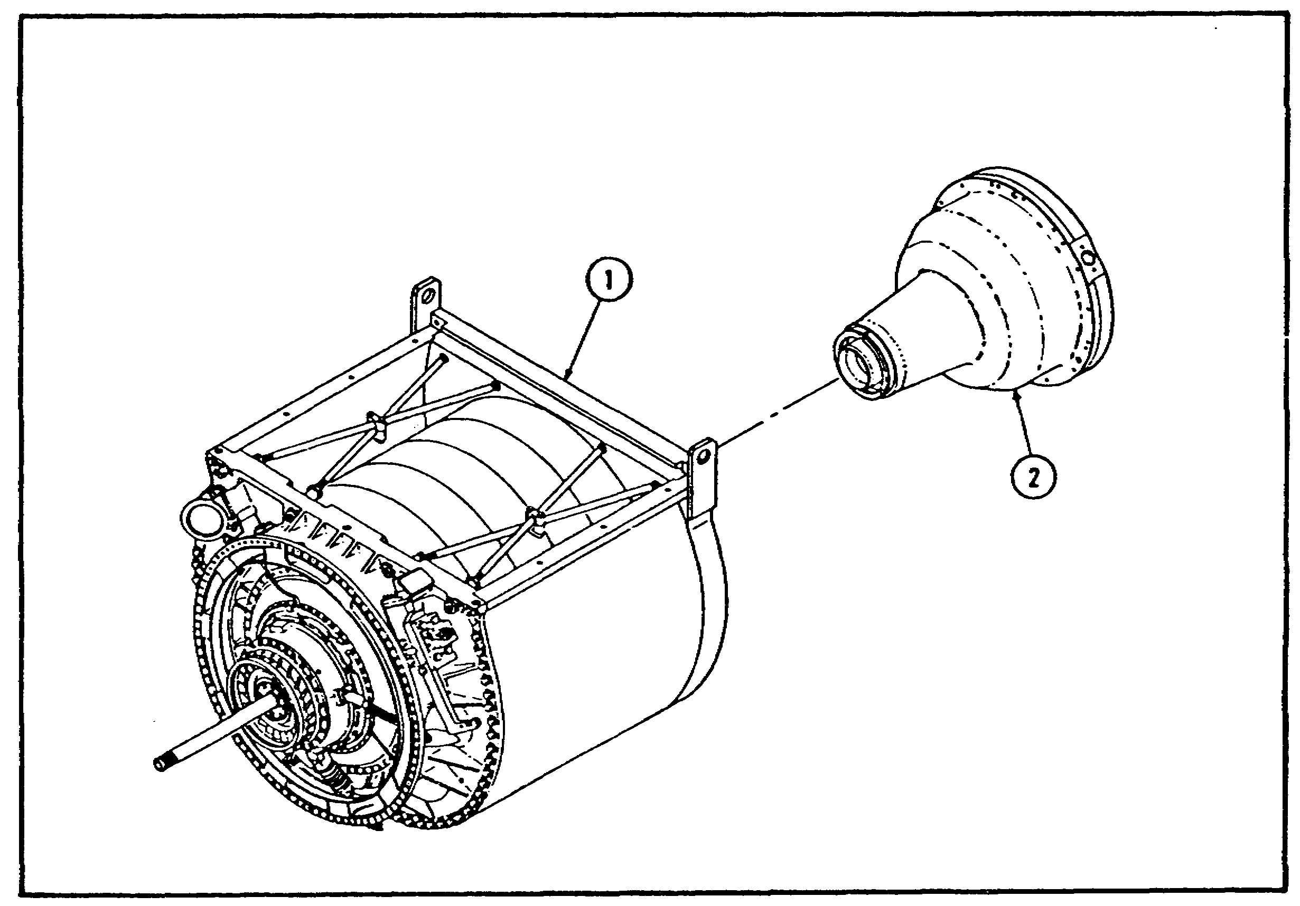

FIGURE 18. REAR ENGINE MODULE.

(1) Rear Engine Subassembly. The rear engine subassembly consists of the low pressure nozzle and turbine assembly, power turbine assembly, and the recuperator assembly.

23

M1 ENGINE AND COOLING SYSTEM - OD0486 - LESSON 1/TASK 1

(a) Low Pressure Nozzle and Turbine Assembly. The low pressure nozzle and turbine assembly drives the low pressure compressor via a spline shaft. The low pressure nozzle and turbine assembly is made of a nickel-based alloy.

(b) Power Turbine Assembly. The power turbine assembly consists of one variable and one fixed nozzle. The assembly also houses the two turbine wheels which supply power through the reduction gearing to the vehicle transmission. Like the low pressure nozzle and turbine assembly, the power turbine assembly is made of a nickel-base alloy.

(c) Recuperator Assembly. The recuperator assembly uses heat from the exhaust gases to preheat the compressor discharge air before it enters the combustor. The recuperator assembly consists of nearly 600 nickel-base plates.

(2) Reduction Gearbox Assembly. The reduction gearbox assembly provides the single stage planetary gear reduction at a ratio of 7.5 to 1.

e. Accessory Gearbox Module. The accessory gearbox is a flat box mounted below the compressor castings. The drive is through a quill shaft that is coupled to the bevel gear mesh, within the midframe housing, driven from the high pressure compressor. The box is mounted on three pins, with two mount points on the diffuser and the third on the low pressure compressor casing. The gears within the accessory gearbox are spur gears.

The accessory gearbox also serves as the engine oil pump for all of the rotor bearing locations, in that the scavenge lines all enter the gearbox and, from a sump within the gearbox, the oil pump scavenges the oil to the cooler. By using this approach, one of the gears is used as a dynamic air/oil separator that vents to the oil tank.

The following components are associated with the accessory gearbox. These components are shown in figure 19, on the following page.

o High speed pick - ups (1)

o Oil pump drive pad (2)

o Starter drive pad (3)

24

M1 ENGINE AND COOLING SYSTEM - OD0486 - LESSON 1/TASK 1

o Quill shaft (4)

o Hydraulic drive pad (5)

o HMU drive pad (6)

o Gearbox mounting flange (7)

o Dol pin and clip (8)

o Forward mounting flange (9)

o Drain valve and magnetic plug (10)

o Gearbox air vent tube (11)
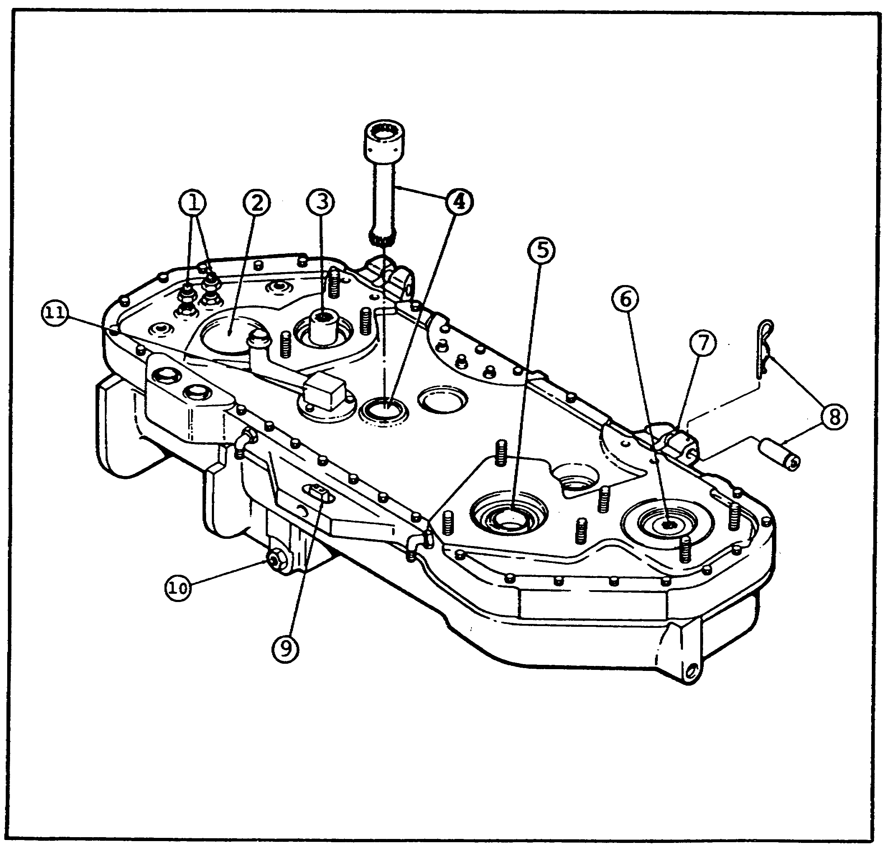

FIGURE 19. ACCESSORY GEARBOX MODULE.

25

M1 ENGINE AND COOLING SYSTEM - OD0486 - LESSON 1/TASK 1

f. Externally Mounted Components. Figure 20 shows a right front view of the engine.
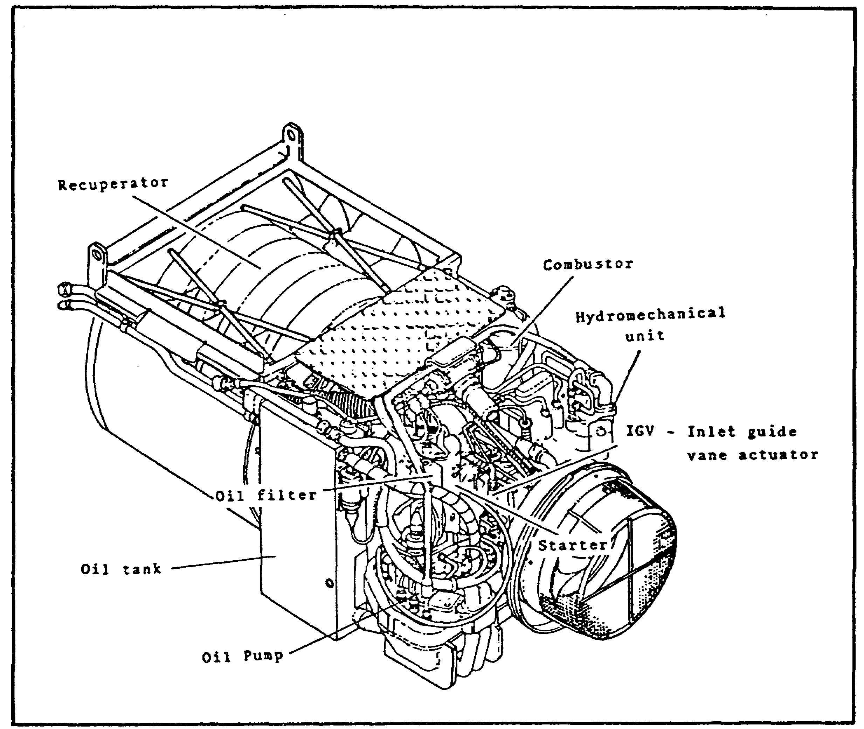

FIGURE 20. EXTERNAL COMPONENTS - RIGHT FRONT VIEW.

Each of the components described will be discussed later in this subcourse. The components that can be located in figure 20 are:

o Oil tank

o Oil pump

o IGV - Inlet guide vane actuator

o Hydromechanical unit

o Combustor

o Starter

26

M1 ENGINE AND COOLING SYSTEM - OD0486 - LESSON 1/TASK 1

o Oil filter

o Recuperator
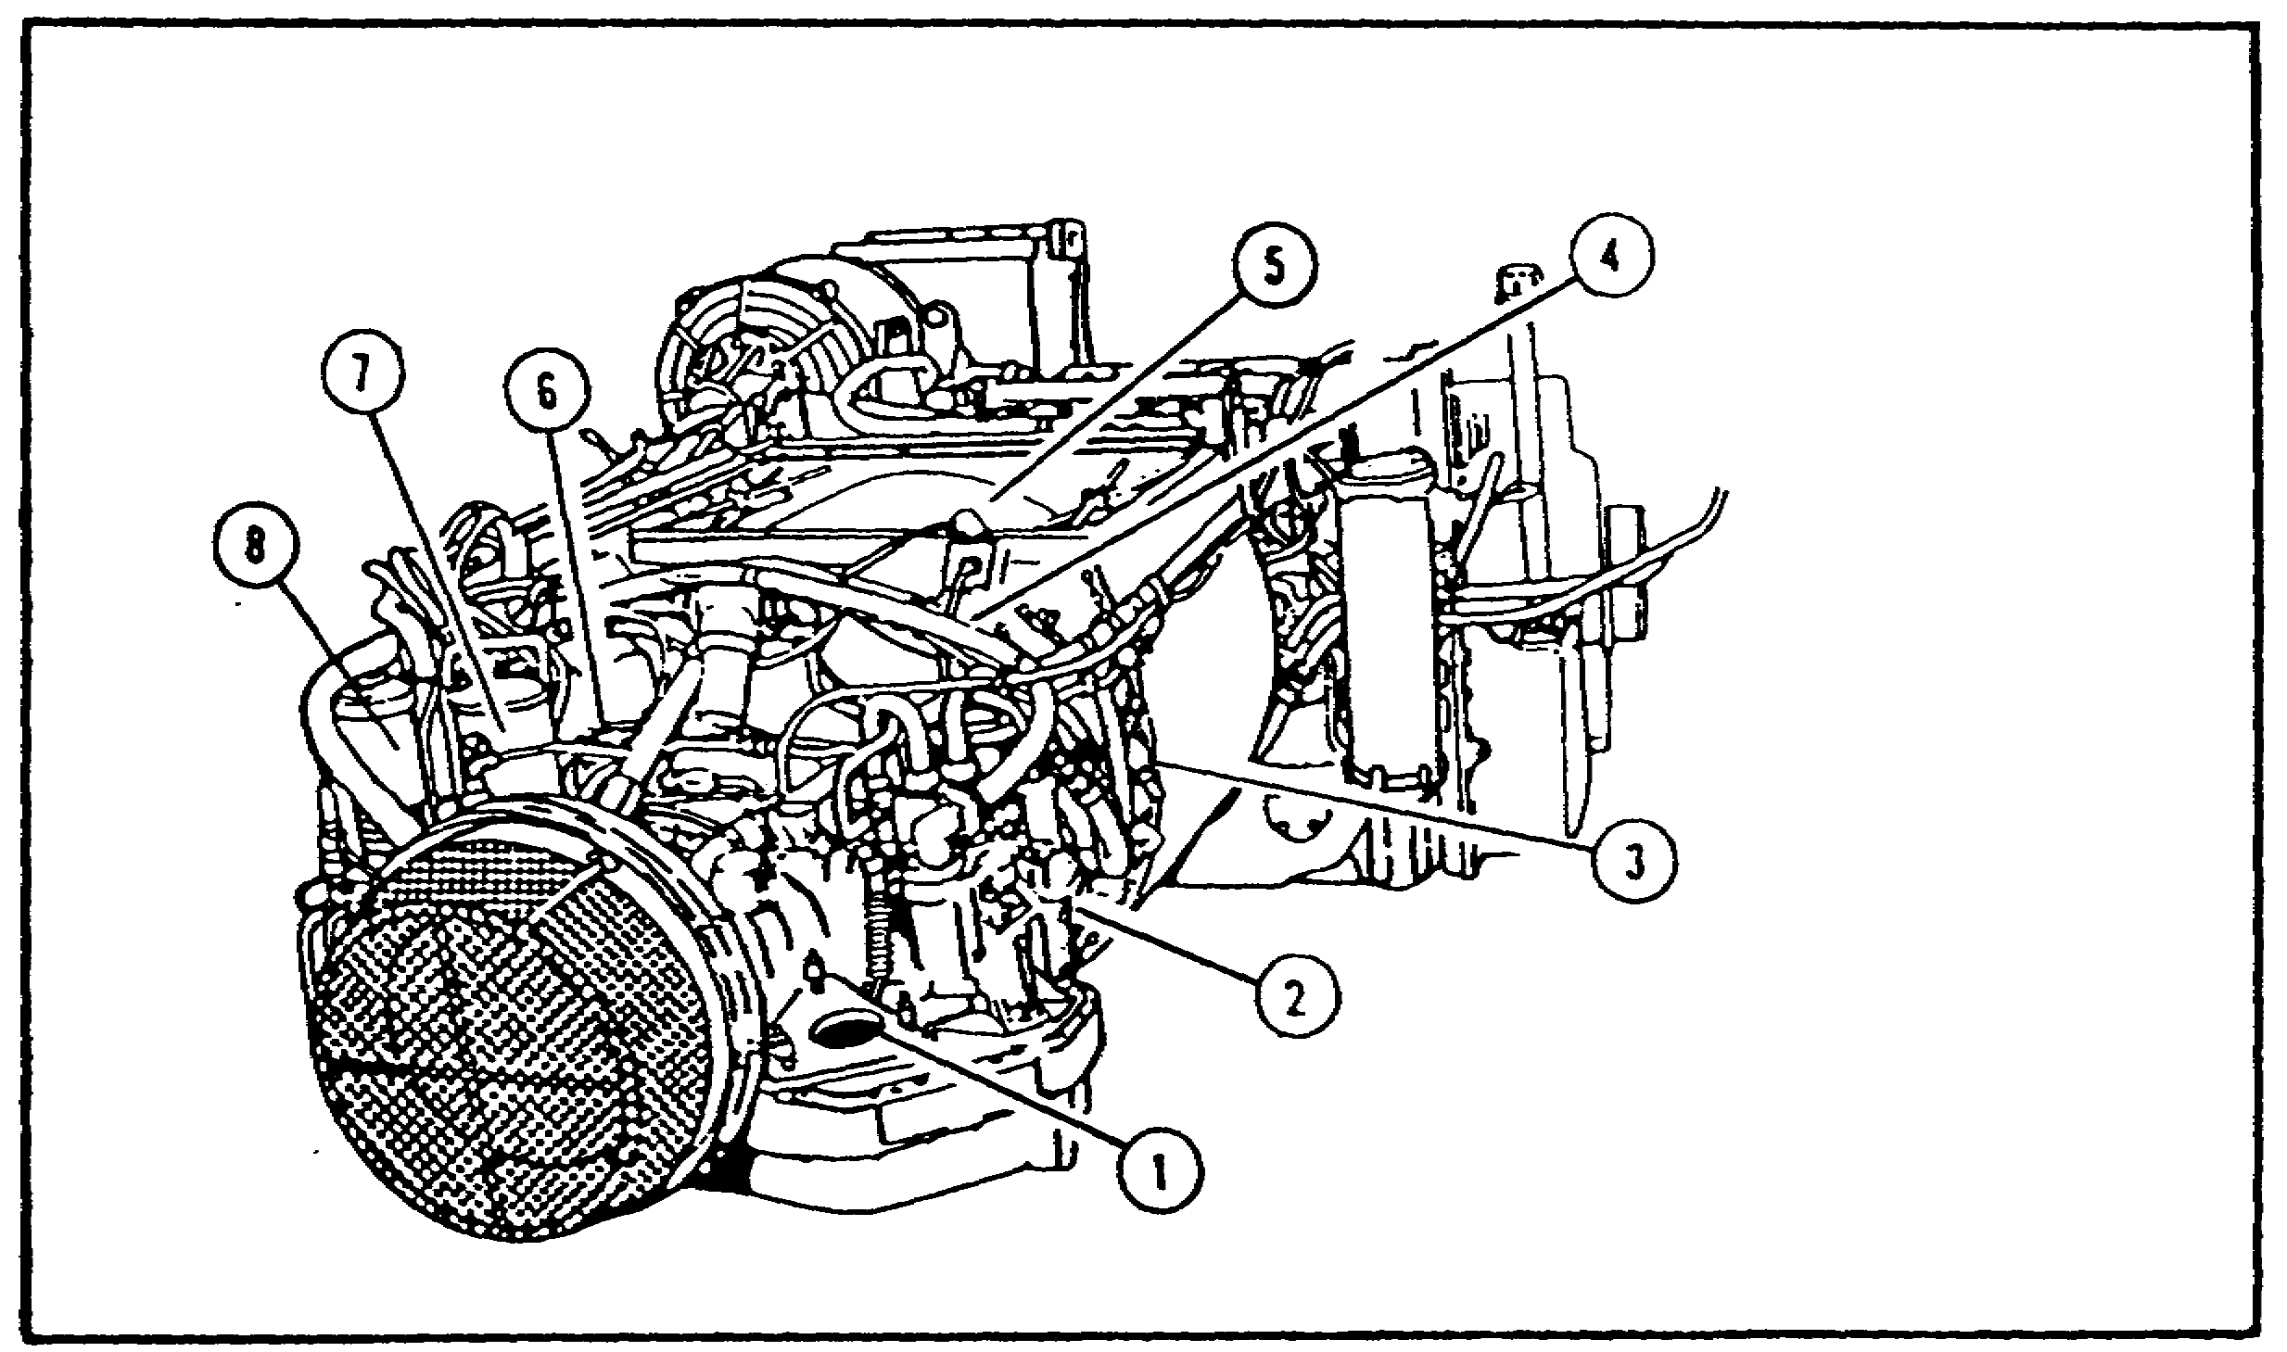

FIGURE 21. EXTERNAL COMPONENTS - LEFT FRONT VIEW.

Figure 21 shows a left front view of the engine. Again, each of the components described in this section will be covered in detail later in this subcourse. The components that can be located in figure 21 are:

o Hydraulic pump drive pad (1)

o HMU (2)

o Power turbine stator actuator (3)

o Combustor dome (4)

o Recuperator (5)

o Air-bleed valve (6)

o Starter (7)

o Oil filter (8)

27

M1 ENGINE AND COOLING SYSTEM - OD0486 - LESSON 1/TASK 1

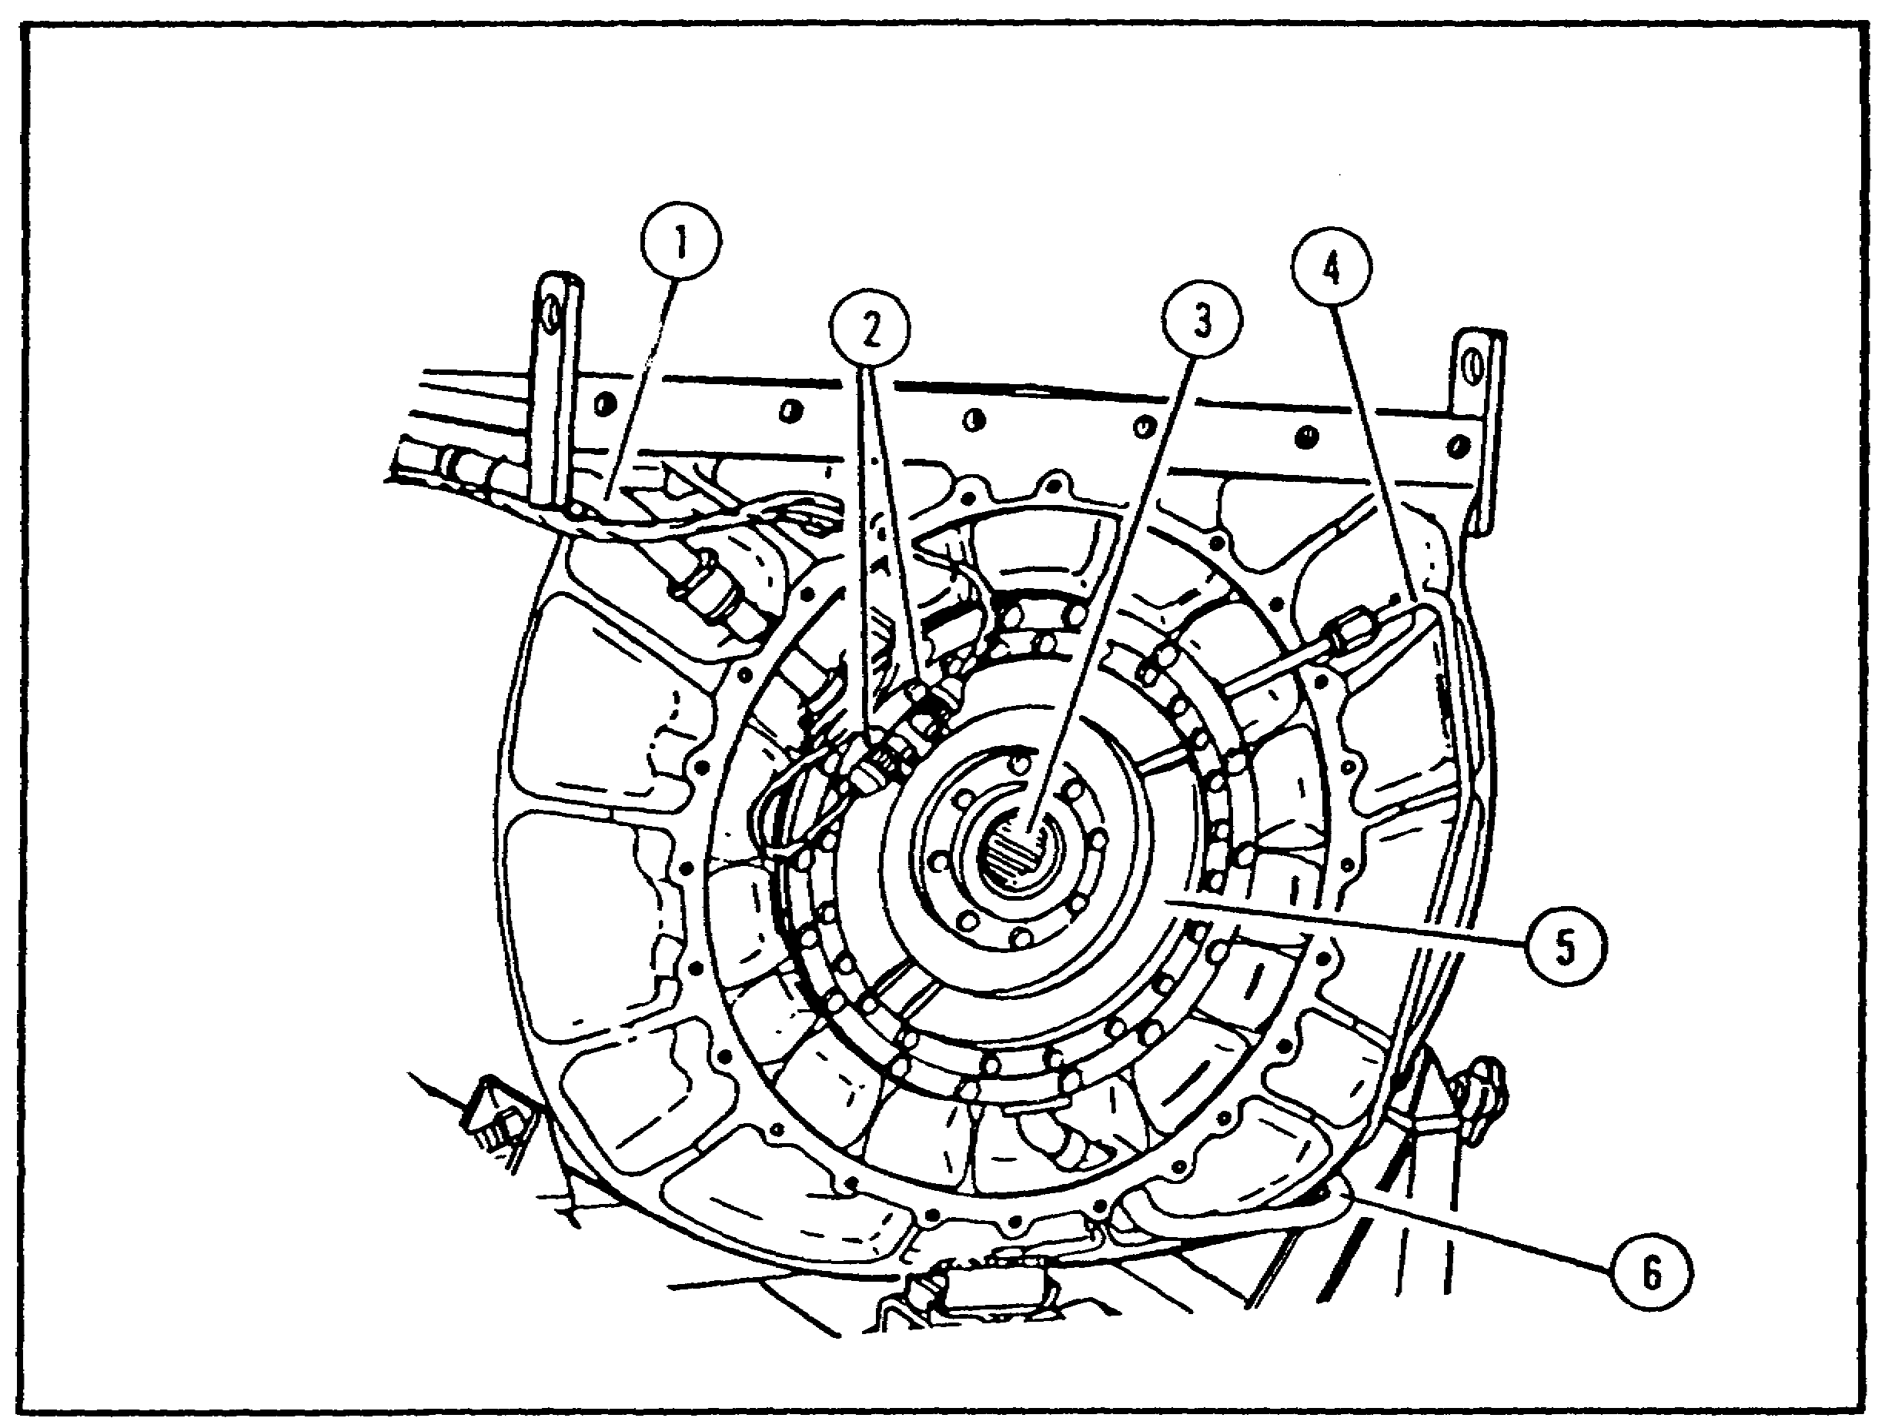

FIGURE 22. EXTERNAL COMPONENTS - REAR VIEW.

Figure 22, shows a rear view of the engine. Each of the components described in this section will be discussed in detail later in this subcourse. The components that can be located in figure 22 are:

o RGB air tube (1)

o Power turbine speed pick - ups (2)

o Power output shaft (3)

o RGB oil feed line (4)

o RGB assembly (5)

o RGB oil scavenge line (6)

g. Main Internal Components. While reading through this section on the main internal components of the AGT 1500 engine, refer to figure 23, on the following page.

28

M1 ENGINE AND COOLING SYSTEM - OD0486 - LESSON 1/TASK 1
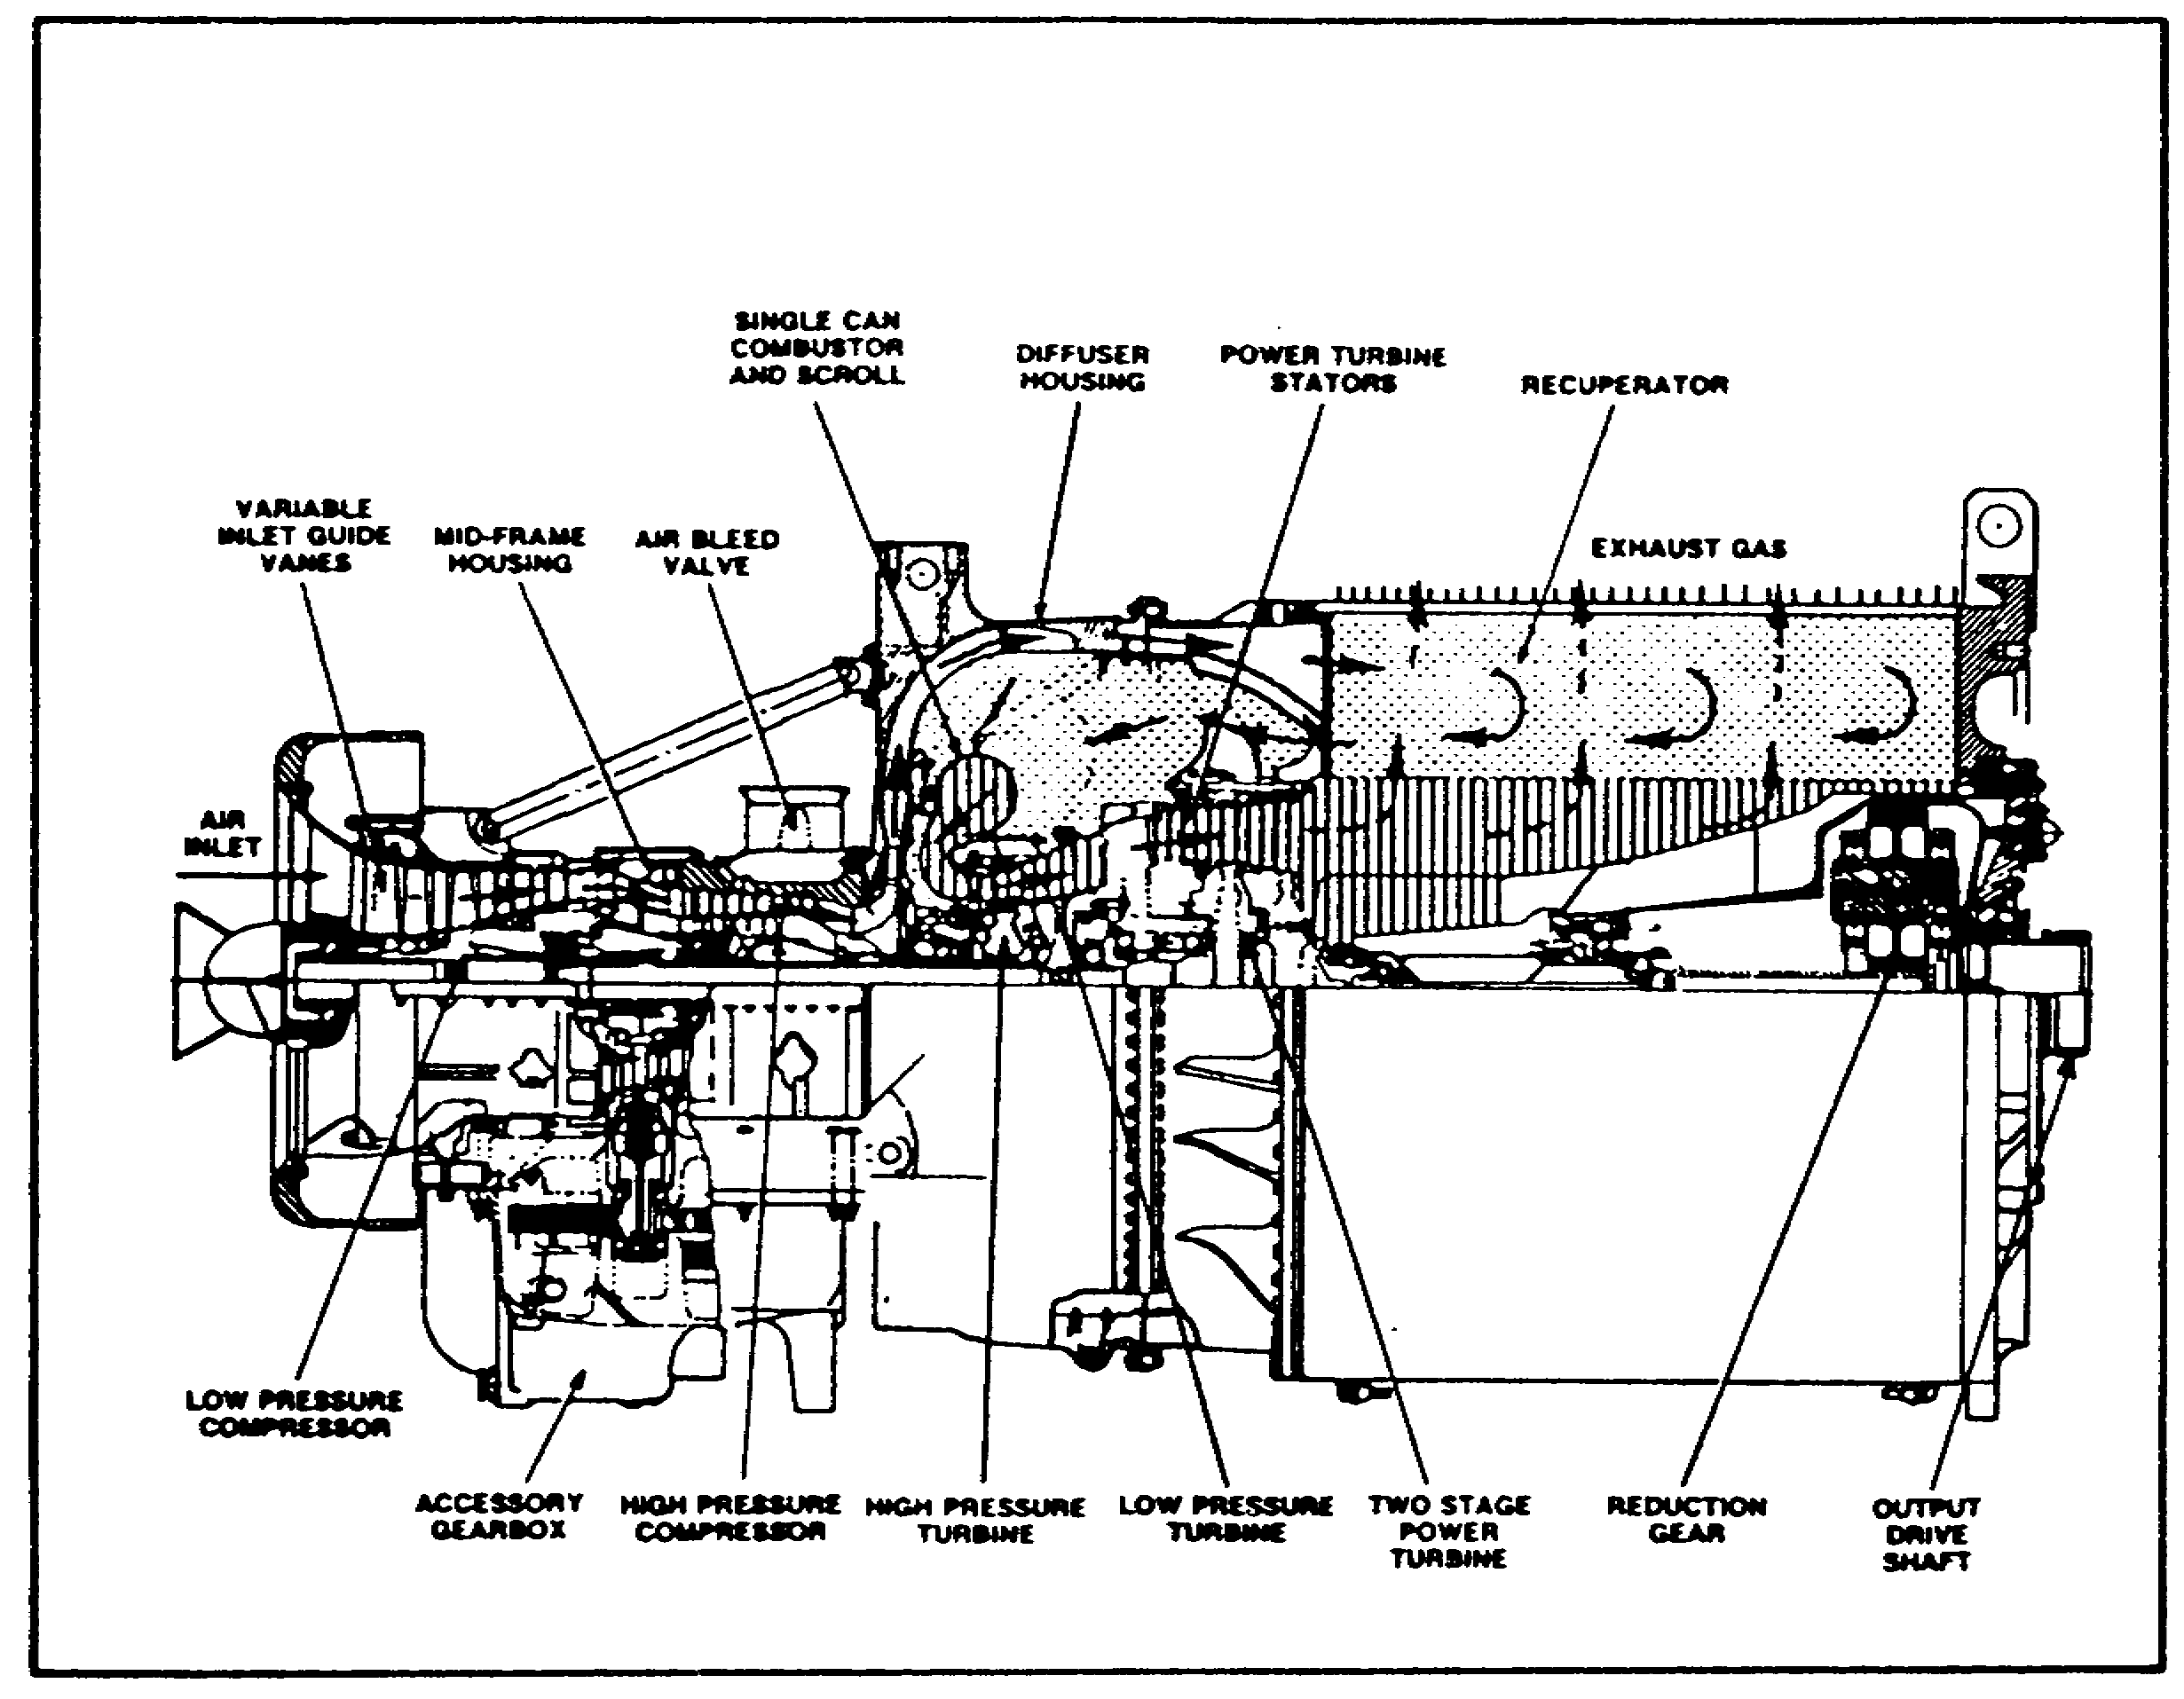

FIGURE 23. MAIN INTERNAL COMPONENTS.

(1) Inlet Housing Assembly.

(a) Inlet. The inlet to the engine is an axial inlet consisting of an outer bellmouth and a hub and bullet nose. Mounted to the bellmouth and hub is the splitter assembly, which assists in directing the air flow from the vehicle plenum into the engine inlet. The hub contains the forward (no. 1) bearing of the low pressure compressor. A flange is provided aft of the outer bellmouth to attach a seal between the engine inlet and the vehicle inlet plenum by use of a quick disconnect arrangement. An inlet screen is also mounted to the bellmouth.

(b) Inlet Guide Vanes. A set of variable inlet guide vanes (igv) are located behind the inlet support struts. These vanes are driven by a unison ring, actuated by the fuel pressure through a crank from outside the engine (igv actuator). The inlet guide vanes direct air for the proper impingement upon the first stage of the twin-spool

29

M1 ENGINE AND COOLING SYSTEM - OD0486 - LESSON 1/TASK 1

axial compressor and assist in preventing compressor stalls.

The guide vanes change their angle in relation to the high pressure compressor speed (30 degrees travel). During starting, the vanes are closed; they begin to open at 85 percent compressor speed and are fully open at 90 percent compressor speed.

(2) Low Pressure (LP) Compressor. The LP compressor case is a two-piece housing (upper and lower half) joined at the axial split line. This case houses five brazed stator assemblies. The five-stage axial LP rotor is supported by the no. 1 bearing in the inlet housing, and the no. 2 bearing in the mid-frame housing.

(3) Mid-Frame Housing. The mid-frame housing ducts the air from the exit of the LP compressor to the inlet of the HP compressor. Four struts, located vertically and horizontally, connect the inner and outer wall structurally. The mid-frame housing provides the bearing support for the aft LP compressor bearings (no. 2) and the forward HP compressor bearing (no. 3). The bevel gear drive, from the HP compressor rotor to the accessory gearbox, is contained in this housing with the bevel gear shaft passing through the bottom strut.

The top strut is used to bring pressurized lubricating oil to the no. 2 and no. 3 bearings. The lower strut serves as a scavenge passage for the oil, which drains directly into the accessory gearbox.

(4) High Pressure (HP) Compressor. The HP compressor consists of a four-stage axial rotor and a centrifugal impeller. The case houses four brazed stator assemblies, the last stage consisting of a double row of vanes. The HP rotor is supported by the no. 3 bearing in the mid-frame housing, and the no. 4 bearing in the diffuser housing.

(5) Air-Bleed Valve. The compressor case is a two-piece (upper and lower half) machined casting, surrounded by a cast two-piece air-bleed manifold with a butterfly type discharge valve. This manifold is fed from slots in the compressor case outside the HP rotor. Air is also extracted through the compressor case to be used for turbine cooling in the turbine module of the engine.

30

M1 ENGINE AND COOLING SYSTEM - OD0486 - LESSON 1/TASK 1

(6) Diffuser Housing. The air diffuser housing, a prime structural component of the engine, provides the forward mounting support for the engine transmission powerpack, as well as the support for the accessory gearbox. The forward flange of the air diffuser supports the compressor cases, the aft flange connects structurally to the forward recuperator housing and, from the inner housing, the aft HP compressor bearing (no. 4) is supported.

The diffuser housing consists of an outer and inner housing. Between the two housings, compressor discharge air is transferred from the HP centrifugal stages, through two vane rows, to the recuperator header.

(7) Recuperator. The function of the recuperator is to use the heat in the exhaust gases to preheat the compressor discharge air, before it enters the combustor. The forward recuperator header is also a structural casting, in that it provides support for the power turbine assembly and the recuperator core. The aft recuperator housing provides aft support for the core and reduction gearbox. The recuperator core is constructed of about 600 embossed cast alloy wave plates, welded in a manner which allows gases to flow between them.

(8) Combustor and Scroll. Within the diffuser housing, and accessible through a top cover on the left side, is the single can combustor and the distribution scroll that channels the combustor gases uniformly to the HP turbine nozzle. A dome-shaped cap, bolted to the combustor housing top, mounts the fuel nozzle and igniter, and positions the combustor liner. Removal of the cap yields complete accessibility to the combustor liner.

(9) High Pressure (HP) Nozzle and Turbine. The HP nozzle vanes are convergently shaped to form passages which increase the velocity and reduce the pressure of the escaping gases. These nozzles discharge the gases at the proper angle for impingement on the HP turbine blades. The nozzle vanes and turbine blades have internal passages through which cooling air is introduced. The HP turbine drives the HP compressor.

(10) Low Pressure (LP) Nozzle and Turbine. The LP nozzle vanes are also convergently shaped and

31

M1 ENGINE AND COOLING SYSTEM - OD0486 - LESSON 1/TASK 1

perform similar functions to the HP nozzle. In order to extract the maximum energy available from the expanding gases exiting the HP section, the cross-sectional area of the LP section is gradually increased. The LP turbine rotor is an uncooled, integrally bladed, cast turbine wheel, to which the splined shaft, which drives the LP compressor, is attached. The rotor is supported aft by the no. 5 bearing.

(11) Power Turbine Assembly. The power turbine housing is the gas connecting duct between the LP and power turbines; it also serves as the bearing support housing for the LP turbine bearing (no. 5) and the power turbine bearings (no. 6A and 6B). Twelve thermocouples, equally spaced on the outer wall, are installed at different predetermined immersion depths into the gas path in order to measure the turbine inlet temperature.

(12) Power Turbine Stators (PTS). The first row of the PT nozzles is a variable nozzle row. All of the vanes in this row are driven by a ring gear actuated through a crank from outside of the engine. PTS scheduling is accomplished by the electronic control unit as follows:

o The power turbine stators are held open until 71 percent high pressure compressor speed is reached. At 71 percent high pressure compressor speed, and during steady operations, the power turbine stators move to schedule the power turbine inlet temperature. A decrease of the high pressure compressor speed to 64 percent will again open the power turbine stators. During engine acceleration the power turbine stators go to the full open position. During deceleration, the power turbine stators go to the full closed position. If the power turbine inlet temperature exceeds the maximum allowable, the power turbine stators will also go to the full open position. If the power turbine speed exceeds 107-109 percent, the power turbine stators go to the full open position and the metered fuel resets to a deceleration schedule.

The second PT nozzle is a fixed nozzle.

(13) Power Turbines. Both power turbines are tip shrouded, integrally cast turbine wheels. They are supported by the two bearings (nos. 6A and 6B). The cross-sectional area of the PT section is also gradually increased in order to extract the maximum

32

M1 ENGINE AND COOLING SYSTEM - OD0486 - LESSON 1/TASK 1

energy available from the expanding gases. The power turbines are mated to the reduction gearbox by a splined quill shaft.

(14) Reduction Gearbox. The reduction gearbox is a single-stage planetary reduction giving an output speed of 3000 rpm (7.5 to 1 gear reduction). The gear housing is a casting within which a carrier for three planetary gears and a ring gear are supported. The gearbox is cantilever mounted from the aft recuperator housing and tucked within the recuperator core. A heat shield is provided around the gearbox and cooling air is provided between the heat shield and the gearbox, to reduce the heat input from the exhaust gases to the gearbox.
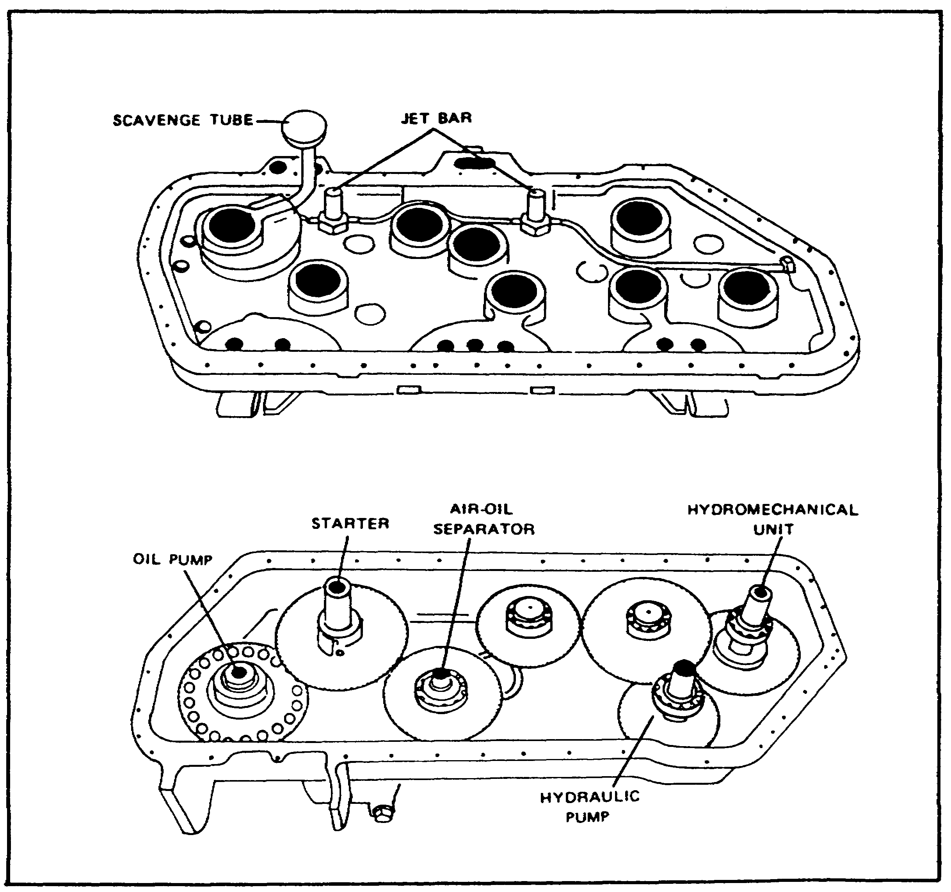

FIGURE 24. ACCESSORY GEARBOX INTERNAL COMPONENTS.

33

M1 ENGINE AND COOLING SYSTEM - OD0486 - LESSON 1/TASK 1

(15) Accessory Gearbox. Figure 24, on the previous page, depicts the split halves of the accessory gearbox. The top half contains jet bars which spray oil onto the spur gears, an oil scavenge tube, and the high pressure speed pickups. The bottom half contains the spur gears which drive the accessories, the quill shaft drive, air-oil separator gear, and the channels which route the oil to be scavenged.

h. Principles of Operation and Airflow. Upon activation of the start circuit, the rotational energy of the starter is transferred, through the spur gears and the quill shaft in the accessory gearbox, to the bevel gear mesh within the midframe housing in order to begin rotation of the high pressure compressor.

As the compressor speed increases, filtered air is drawn into the axial inlet from a plenum chamber in the vehicle and is directed, as uniform pressure, through the variable inlet guide vanes (igv) to the five-stage axial low pressure compressor. Some of the air is ducted, via external plumbing from the low pressure compressor housing, to the reduction gearbox to provide cooling air for the gearbox. At the exit of the low pressure compressor, the air passes through the mid-frame housing to the high pressure compressor. The high pressure compressor is comprised of four axial stages and a centrifugal stage.

As it becomes necessary, air is bled from slots in the high pressure compressor case into the air-bleed manifold, to be discharged overboard by the air-bleed valve. This action assists in maintaining a balanced relationship between compressor rotational speed and airflow velocity, thereby preventing compressor stall and subsequent surging in the low rpm ranges. In addition, pressurized air is drawn from the compressor case via external plumbing, to provide cooling and more effective oil scavenging of the numbers 2, 3, 5, and 6 bearings.

The air exits the high pressure compressor through a two-stage vane diffuser which channels the air radially outward and aft to the recuperator housing. A 14.5 to 1 pressure ratio is achieved by the twin-spool compressor. The resulting compression has increased the air pressure and

34

M1 ENGINE AND COOLING SYSTEM - OD0486 - LESSON 1/TASK 1

temperature, decreased the volume, and maintained a constant air velocity.

Prior to entering the recuperator, a portion of the compressor discharge air in the diffuser is drawn off, through internal passages, to the combustor dome where it enters the fuel nozzle to assist in fuel atomization and cooling of the fuel nozzle. The compressed air enters the recuperator core through the "triangles" (figures 25 below, and 26, on the next page), passes between the plates, is preheated by the exhaust gases, and exits the recuperator forward through the "footballs". The preheated air is directed into the inner diffuser housing plenum and enters the single can combustor. At this point, air is mixed with the fuel supplied by the single fuel nozzle; spark is introduced by the single igniter plug; and the resulting combustion produces hot expanding gases.

NOTE

The igniter plug is required for the start sequence only. Combustion is sustained as long as proper fuel/air ratio exits.

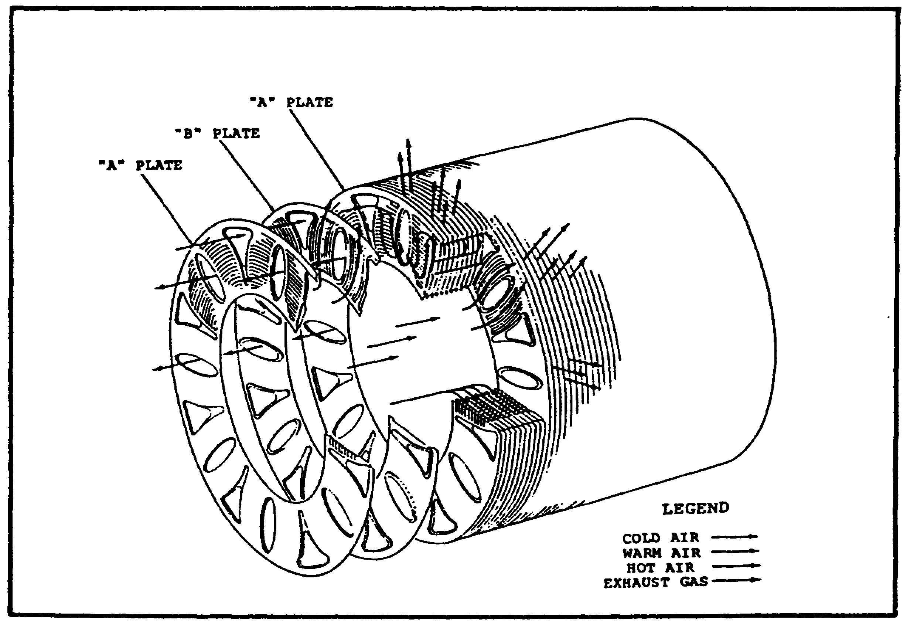

FIGURE 25. PRINCIPLES OF OPERATION -
RECUPERATOR.

35

M1 ENGINE AND COOLING SYSTEM - OD0486 - LESSON 1/TASK 1

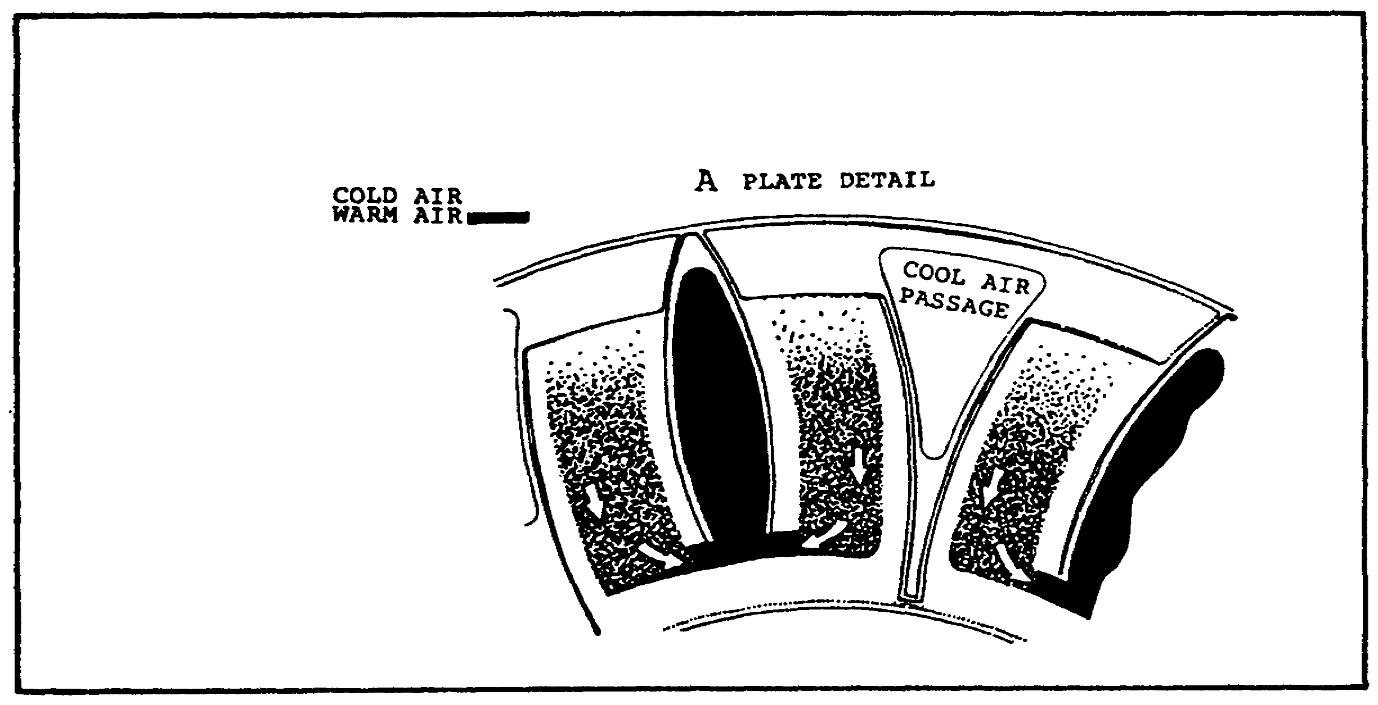

FIGURE 26. RECUPERATOR PLATE DETAIL.

A part of the preheated airflow is referred to as "primary" air. A portion of the primary air enters the combustion chamber directly through holes in the liner to create a stable aerodynamic flame holder. Another portion of the primary air dispenses in thin films along the inner surfaces of the combustion chamber liner to protect these surfaces from the 3000 degrees to 3500 degrees Fahrenheit flame temperatures. This protective air film helps to keep carbon and fuel residue from depositing on the chamber surfaces.

Another part of the airflow is diverted into the hot exhaust stream leaving the primary combustion zone. This diverted air is called the "secondary" air; it serves to cool the hot product of combustion prior to entering the turbine stages. The penetration and mixing characteristics of this secondary air are such that an optimum radial and circumferential temperature distribution is maintained within and surrounding the scroll.

The gases leaving the combustion chamber pass first through the high pressure nozzle and the high pressure turbine. The high pressure turbine extracts enough energy from the accelerating gases to drive the high pressure compressor. From the high pressure turbine, combustion gases next pass through the low pressure nozzle for the proper impingement on the low pressure turbine. The low pressure turbine extracts sufficient energy from the gases to drive the low pressure compressor.

36

M1 ENGINE AND COOLING SYSTEM - OD0486 - LESSON 1/TASK 1

The gases are then ducted through the power turbine housing, passing through the variable power turbine stator-(pts) nozzles, to impinge directly on the first stage power turbine wheel. Then the gases pass through a fixed nozzle and the second stage power turbine wheel. Most of the energy remaining in the gases is extracted by the power turbine stages to supply power, via a splined shaft, directly to the reduction gearbox (rgb). The reduction gearbox reduces the high rotational speed of the power turbines to a maximum of 3000 rpm at the output drive shaft. The output drive shaft is connected to the vehicle transmission; thus, power is introduced into the vehicle final drives.

The exhaust gases pass radially outward through the recuperator core into a collection of plenum which is connected to the vehicle exhaust duct. Upon completion of the engine start, the role of the bevel gear drive in the mid-frame housing is reversed, so that it now provides continuous drive for the accessories mounted to the accessory gearbox.

6. Conclusion

In this task of the subcourse, the components that comprise the AGT 1500 gas turbine engine were discussed. In addition, the principles of operation and a comparison of gas turbine engine versus the reciprocating engine were also discussed.

It is easy to see from this task why the gas turbine engine is a much more efficient engine, that produces great amounts of power.

In the task that follows, some of the auxiliary systems that comprise and work with and from the AGT 1500 gas turbine engine will be discussed.

37

M1 ENGINE AND COOLING SYSTEM - OD0486 - LESSON 1/TASK 2

LESSON 1

CONSTRUCTION OF THE AGT 1500 C TURBINE
ENGINE, SUPPORTING SYSTEMS, CONTROLS
AND MONITORING DEVICES - M1 TANK

TASK 2. Describe the supporting systems, controls, and monitoring devices of the AGT 1500 C turbine engine.

CONDITIONS

Within a self-study environment and given the
subcourse text, without assistance.

STANDARDS

Within 2 hours

REFERENCES

No supplementary references are needed for this task.

1. Introduction

In task one of this lesson, the theory of operation, construction, and a comparison of reciprocating and turbine engines were discussed.

For the AGT 1500 turbine engine to operate properly and efficiently, it must incorporate various support systems, such as the air induction and lubrication systems. In addition, there also must be controls and monitoring devices permitting the operator to control and check the engine to ensure that it is operating properly.

These supporting systems, controls, and monitoring devices are the subject of this task. The task will start with the support systems, then progress to the controls, and end with the monitoring devices.

38

M1 ENGINE AND COOLING SYSTEM - OD0486 - LESSON 1/TASK 2

2. Support Systems

There are seven support systems that are required to ensure efficient operation of the AGT 1500 turbine engine. Each of these support systems will be discussed in the paragraphs that follow.

a. Air System. The AGT 1500 has an air system comprised of tubes, ducts, linkages, and an air-bleed valve.

(1) Purpose of the Air System. The purpose of the air system is two-fold. First, it supplies pressurized cooling air to various engine components. Secondly, through the air-bleed valve, it assists in maintaining the proper airflow through the compressors.

(2) Air System Operation. When the high pressure compressor is rotating, pressurized air is continuously being ducted to bearings 2, 3, 5, and 6 to provide cooling and more effective oil scavenging of these bearings. The low pressure compressor supplies cooling air for the reduction gearbox. The air-bleed valve is attached to the inlet guide vane actuator by an actuating rod and linkage. Thus, the valve is operated by, and in direct relation to, the inlet guide vanes position. The air-bleed valve is fully open during idle engine speed conditions. The valve begins to close as the high pressure compressor speed increases. It becomes fully closed at approximately 90 percent high pressure compressor speed.

b. Lubrication System. The lubrication system is a recirculating, pressure (feed), return (scavenge) type system, containing a five element pump, oil filter, and various oil pressure and temperature sensing devices.

(1) Purpose of the Lubrication System. The lubrication system is designed to clean, cool, and lubricate the internal components of the engine. The entire system is completely self-contained within the powerpack. The lubrication system uses three basic oil filters.

(2) Lubrication System Operation. The lubrication system uses a five element pump that is driven by the accessory drive gears. The pump causes oil to flow throughout the system.

39

M1 ENGINE AND COOLING SYSTEM - OD0486 - LESSON 1/TASK 2

Oil, from the engine oil tank, is pumped by a pump element. This oil goes through a check valve, which opens at 1 to 3 psi and closes, to keep oil from flowing, when the pump is not operating. At the same time, the oil is circulating through a pressure regulating valve, regulating the oil pressure to 100 ± 10 psi. The oil then passes through the filter bypass valve (which closes at 20 psi, to allow oil flow in the event of a clogged oil filter), to the clogged filter switch (which activates at 13 psi to indicate impending internal failure). The oil then flows through the oil filter. Oil exiting the filter takes three paths: It flows directly to numbers 2 and 3 bearings; it flows to the programming valve; and, it flows through the manifold check valve, which has a cracking pressure of 15 psi, to the oil manifold.

The programming valve closes at high oil pressure allowing all of the oil to lubricate vital engine components. At low pressure, as during shutdown, the valve opens and most of the oil goes to the accessory gearbox. This-lowers the oil flow to the bearings and lets the scavenge system work more efficiently.

The oil manifold has seven outlets: oil temperature sensor; oil pressure switch; number 1 bearing; the accessory gearbox; the reduction gearbox; number 4, 5, and 6 bearings.

The oil is scavenged, from the numbers 2, 3, 4, 5, and 6 bearings, by the gravity feed to the accessory gearbox. The number 1 bearing is scavenged by a pump element feeding the oil to the accessory gearbox.

After scavenging by their respective pump elements, (the accessory gearbox and the reduction gearbox) scavenge oil leaves the oil pump, via a scavenge check valve, through a common line to the oil cooler. The oil is filtered both before and after the cooler. The cooled oil then flows back to the oil tank for recirculation.

If air is introduced into the system, it must be vented. This is accomplished by means of an air/oil centrifugal separator. After the action by the separator, the air is vented through a tube from the top of the accessory gearbox, through the top of the oil tank, to the recuperator housing.

40

M1 ENGINE AND COOLING SYSTEM - OD0486 - LESSON 1/TASK 2

c. Electrical System. The electrical system provides circuitry to support starting, ignition, steady state operation, and all engine-oriented electrical monitoring devices. Components include the electronic control unit, starter pilot relay, starter, ignition exciter, lead, and igniter plug, maintenance indicator harness, thermocouple harness, fuel management harness, and hull interface connectors. When the engine is running, the power is supplied by an alternator which is driven by the rear power take off on the transmission. The alternator produces between 27.5 and 28.5 volts direct current. In addition, the M1 has a governor control system, which is part of the electrical system. The governor control system limits the engine to a maximum speed of 3100 rpm, which corresponds to the maximum vehicle speed of 45 mph. The governor has rapid response and will protect the engine against a sudden loss of load at full power.

(1) Electronic Control Unit. The electronic control unit is an electronic computer that controls engine operation. The electronic control unit receives signals from the vehicle inputs, engine sensors, and driver inputs; it then delivers output signals to engine accessories and monitoring devices.

(2) Thermocouple Harness. A thermocouple harness assembly, consisting of an electrical connector, a manifold, and twelve chrome-aluminum thermocouples mounted on three harnesses is installed at the power turbine stator inlet. Its function is to measure the power turbine inlet temperature and send an electrical signal to the electronic control unit.

Temperature indications are provided by averaging the readings of all twelve thermocouples. The thermocouples are manifolded into a paralleled circuit, each leg having the same resistance, thereby ensuring an accurate average signal. An average millivolt signal is sent to the electronic control unit via a harness.

(3) Magnetic Speed Pickup Functional Description. A magnetic speed pickup is a permanent magnet behind a soft iron pole piece, around which a coil has been wrapped. The pickup is placed adjacent to a gear of ferrous metal.

41

M1 ENGINE AND COOLING SYSTEM - OD0486 - LESSON 1/TASK 2

When the pole piece is at a gear tooth gap, the magnetic flux lining the coil is low. When a gear tooth comes into line with the pole piece, the magnetic flux liners become stronger and are drawn inward, toward the magnet. The flux liner crossing the coil induces alternating current (ac) voltage proportional to the rate of change of flux liners around the pole piece. Therefore, an electrical frequency speed signal, proportional to the speed at which the ferrous mass (gear tooth) causes the liner flux buildup to increase or decrease, is created.

(4) Electrical Disconnect Panel. The electrical disconnect panel (figure 27) provides the electrical interface between the engine and the tank hull.

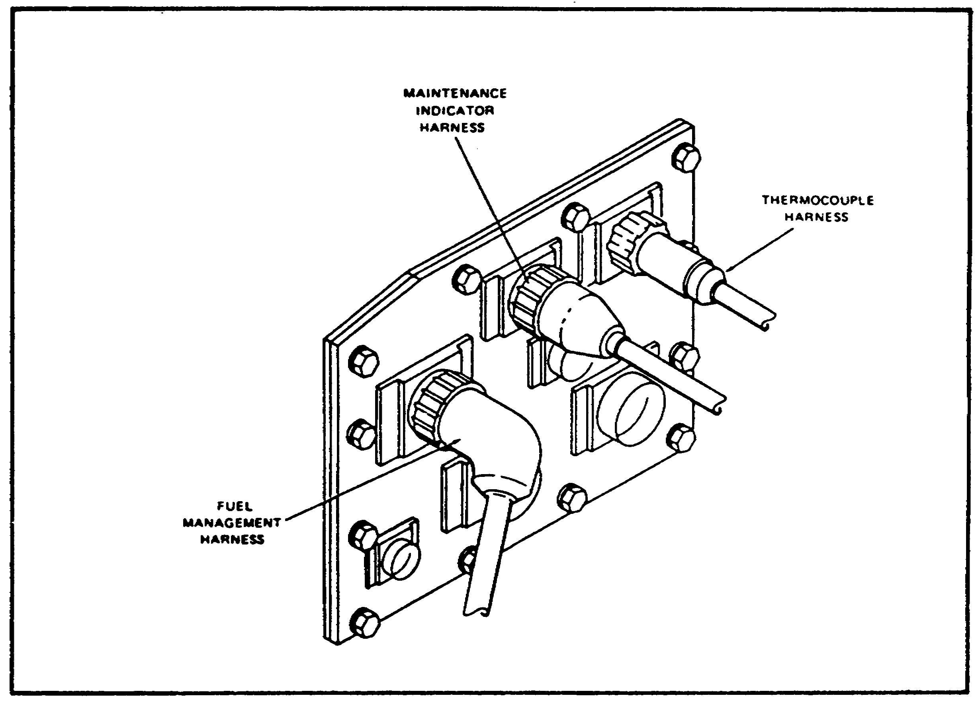

FIGURE 27. ELECTRICAL DISCONNECT PANEL.

d. Fuel Management System. The AGT 1500 gas turbine engine is operated under the control of the electronic control unit and a hydromechanical unit. The combined system provides fully automatic start sequencing and fuel scheduling over the engine

42

M1 ENGINE AND COOLING SYSTEM - OD0486 - LESSON 1/TASK 2

operating range, engine acceleration and deceleration, and inlet guide vane and power turbine stator scheduling. Overspeed and over-temperature protective modes are incorporated into the system.

e. Inlet Guide Vane/Power Turbine Stator.

(1) Inlet Guide Vane Operation. The inlet guide vanes are positioned according to high pressure compressor speed. That is the electronic control unit constantly monitors the high pressure compressor speed, and sends a corresponding signal to the hydromechanical unit. The hydromechanical unit, in turn, meters the fuel flow to position the inlet guide vane actuator, which positions the inlet guide vanes.

Through years of research and experimentation, it has been proven that part-speed operation of multistage compressors (as in the AGT 1500) causes the exit, or rear, stages of compression to choke, which limits the flow in the inlet stages, and causes them to stall.

A basic principle of turbine engine operation is that the amount of air that enters the combustor, from the compressor, must exit the combustor, through the turbines. At low speeds, the power turbines are rotating much more slowly than the compressor. Therefore, the compressor can produce more air than needed, and it chokes on its own air. This causes the air flow across the inlet stages of compression to slow, causing them to stall, and thereby failing to produce the required amount of compressed air.

In order to help relieve this stalling effect (which occurs at low speed operation) adjustable inlet guide vanes can be used before the first stage of compression. By this method, the angle at which the inlet air strikes the first stage of compression is lessened. This delays stalls in the first stage of compression.

If you will remember that the air system contains an air bleed valve which unchokes the rear stages of compression, and combine this with the operation of the inlet guide vanes upon the forward stages of compression, you can see how the AGT 1500 compressor section has been designed to overcome the problems of part-speed operation by controlling the tendency to choke and stall.

43

M1 ENGINE AND COOLING SYSTEM - OD0486 - LESSON 1/TASK 2

At low engine speeds, below approximately 86 percent of high pressure compressor speed, the inlet guide vanes will be in their closed position. As the rotor speed increases past 86 percent high pressure compressor speed the inlet guide vanes gradually open. At approximately 90 percent high pressure compressor speed the inlet guide vanes will be in the open position.

(2) Power Turbine Stator Operation. The power turbine stators are operated by the power turbine stator actuator. The hydromechanical unit, directed by the electronic control unit, schedules the fuel flow to the actuator to position the power turbine stators. The power turbine stators position is controlled by a combination of high pressure rotor speed and measured power turbine inlet temperature.

The AGT 1500 operates from very low power to approximately 1000 shaft horsepower in a conventional manner (increased power is obtained by increasing the high pressure turbine inlet temperature). Above 1000 shaft horsepower, additional power is obtained by opening the power turbine stators, which draws more air flow through the engine while maintaining constant high pressure turbine inlet temperature. The increase in the air flow increases the power. By operating in this manner, the engine is able to achieve a low specific fuel consumption (sfc) over a wide power range.

f. Fuel Management System Operation.

(1) Sensed Parameters. The electronic control unit: receives input signals in the form of driver requests, engine sensors, and vehicle interface; analyzes these inputs; computes fuel scheduling for the hydromechanical unit; and provides logic for the operation of the engine accessories, fault detection, protective modes, and diagnostic equipment.

(2) Start Scheduling. Vehicle-supplied fuel flows through the engine-mounted inlet fuel filter to the hydromechanical unit fuel pump. Upon activation of the starting circuit, the main fuel valve within the hydromechanical unit is still closed. Voltage is supplied to the starter pilot relay, starter solenoid, ignition exciter, and igniter plug.

44

M1 ENGINE AND COOLING SYSTEM - OD0486 - LESSON 1/TASK 2

At 5 percent high pressure compressor speed, the main fuel valve is opened, and metered fuel flows through the opened solenoid-operated shutoff valve to the fuel nozzle where it is mixed with the preheated air from the recuperator and ignited. A successful start, with all necessary gearbox-mounted accessories operating normally, should be accomplished within approximately 25 seconds at 55 percent high pressure compressor speed. At this time, the electronic control unit removes power from the starter and ignition exciter. As long as the proper proportions of fuel and air supply are maintained, the flame within the combustor chamber is sustained.

If 60 seconds have elapsed and the high pressure compressor speed is below 55 percent, the electronic control unit automatically aborts the start sequence by deactivating the starter and ignition exciter circuits, and energizing the shutoff and main fuel valves closed. Additional shutdown logic is provided throughout the start sequence if the electronic control unit detects vehicle, engine and control sensor failures.

(3) Steady State Fuel Scheduling. The electronic control unit schedules fuel flow as a function of the driver's throttle control. The inlet guide vanes and power turbine stator feedback cable transducers provide the electronic control unit with information. The control unit computes the relationship between requested and actual positions of the inlet guide vanes and the power turbine stators.

(4) Accelerations/Decelerations. The electronic control unit computes throttle requests for acceleration or deceleration, and commands the hydromechanical unit to increase or decrease fuel flow corresponding to the high pressure compressor speed. Power turbine inlet temperature and engine inlet temperature factors are also computed during accelerations. Accelerations are accomplished with the power turbine stators opened; during decelerations the power turbine stators are closed.

g. Engine Limit Circuits.

(1) Power Turbine Inlet Over-temperature. The maximum allowable power turbine inlet over-temperature is slightly over 1600 degrees F.

45

M1 ENGINE AND COOLING SYSTEM - OD0486 - LESSON 1/TASK 2

During this condition, the power turbine stators are slewed wide open and fuel is metered on a decelerated schedule until the temperature stabilizes below the limit. Various other limits are programmed into the electronic control unit to protect against over-temperatures during starting, accelerations, and steady state operations.

(2) Power Turbine Overspeed. The power turbine overspeed point is set between 107-109 percent. If an overspeed is detected, the power turbine stators go to full open and the fuel is metered on a decelerated schedule until the speed decreases to 95 percent. Upon resumption of normal operations, the power turbine stators assume a position consistent with normal high pressure compressor speed and power turbine inlet temperature ranges.

h. Protective Mode Provisions. The electronic control unit is designed to detect vehicle, engine, and control sensor failures during starting and steady state operation. This protection is provided by activation of the following fault modes as appropriate: Mode I, during which the electronic control unit issues a stop command; Mode II, which limits the fuel flow between 62-292 pounds per hour; Mode III, which limits a fixed fuel flow of 125 pounds per hour.

3. Controls

The electronic control unit and the throttle are actually the only two engine controls in the tank. These are the only items that control the operation of the engine. Each of these components will be discussed in detail in the paragraphs that follow.

a. Electronic Control Unit. Figure 28, on the following page, is an illustration of the electronic control unit. The electronic control unit is a white cast aluminum box which is mounted in the crew compartment. It acts like a computer which monitors specific controls and engine data, analyzes the control signals and engine data, then sends the proper electronic signal to the electromechanical fuel system on the engine to start and keep the engine running. Input signals are also provided to the driver's maintenance indicator panel. The electronic control unit also monitors the power turbine stator and inlet guide vane actuator's feedback signal from the electromechanical fuel control system.

46

M1 ENGINE AND COOLING SYSTEM - OD0486 - LESSON 1/TASK 2

The controls which feed the electronic control unit are the start/stop switch and the speed select (throttle). Signals sent to the electromechanical fuel system are the power turbine stator signal, inlet guide vane signal, and the proportional fuel signal. Provisions are included for a backup fuel flow, if needed, and a fuel shutoff signal.
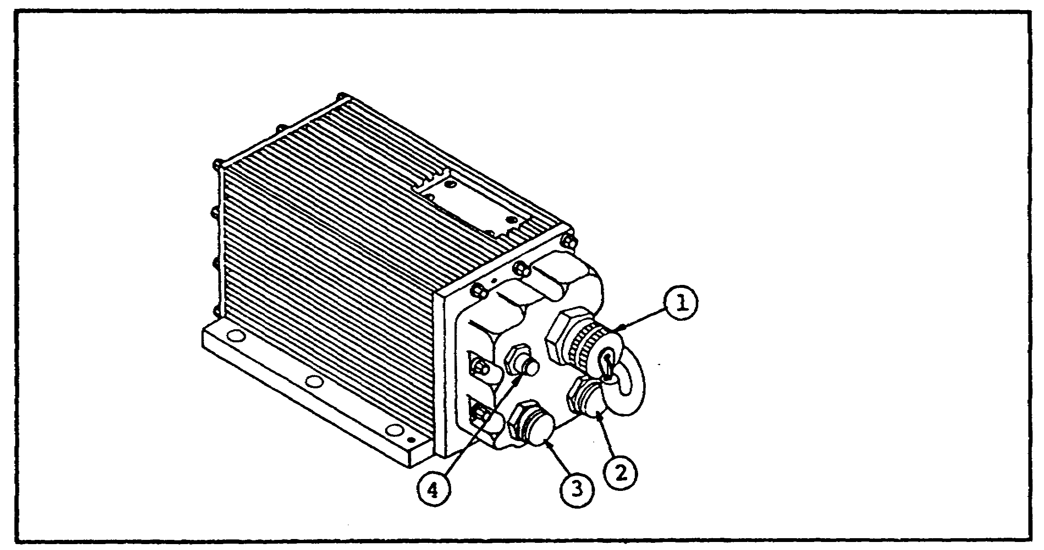

FIGURE 28. ELECTRONIC CONTROL UNIT.

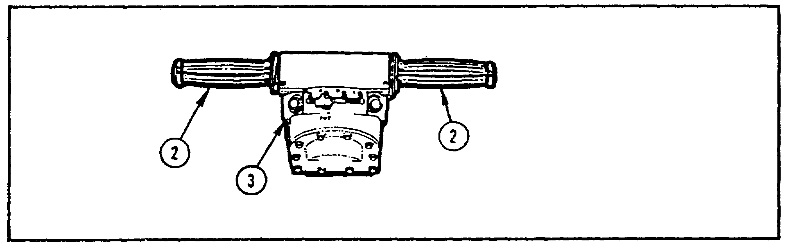
FIGURE 29. STEER-THROTTLE CONTROL.

b. Throttle.
(1) Purpose of the Throttle. The throttle controls engine speed. Engine speed is controlled by the twist grips (2, figure 29) on the steer-throttle control (3). Both twist grips turn in the same direction and either can be used to control the engine speed. A higher (tactical) idle can be selected by setting the TACTICAL IDLE switch to ON.

47

M1 ENGINE AND COOLING SYSTEM - OD0486 - LESSON 1/TASK 2

This will raise the idle speed from normal, which is 870-950 rpm, to between 1250 and 1350 rpm.

(2) Throttle Operation. The driver advances the throttle (turns the twist-grip) on the steer-throttle control. An electrical signal is sent to the electronic control unit, which in turns sends an electrical signal to the electromechanical fuel system. The electromechanical fuel system takes these electronic signals, received from the electronic control unit, and converts them to usable energy to control and direct fuel flow. The fuel flow is directed to the fuel nozzle and to the power turbine stator and inlet guide vane actuators. Feedback cables, from the power turbine stator and the inlet guide vane actuators to the electromechanical fuel system, allow the electromechanical fuel system to return a feedback signal to the electronic control unit.

4. Monitoring Devices

The word "monitoring" is defined as supervising or keeping watch over. The word "devices" is defined as something devised or constructed for a particular purpose. Therefore, a monitoring device is constructed to supervise or keep watch over something; in this case, that something is the operation of the AGT 1500 gas turbine engine.

In the M1 tank, there are five monitoring devices for the AGT 1500 gas turbine engine. One of these is a gage and the remaining four are indicator lights. The five monitoring devices are as follows:

o Tachometer or engine speed gage

o Oil temperature high indicator

o Oil pressure low indicator

o Overspeed indicator

o Gas over-temperature indicator

Each of these monitoring devices will be discussed separately in the paragraphs that follow (see figure 30 on the following page).

48

M1 ENGINE AND COOLING SYSTEM - OD0486 - LESSON 1/TASK 2

a. Tachometer. The tachometer (6) monitors the engine speed and displays a reading in hundreds of revolutions per minute (rpm). The tachometer is mounted on the driver's instrument panel (figure 30).

b. Oil Temperature High Indicator. The oil temperature high indicator (1) will illuminate red if the engine oil is too hot.

c. Oil Pressure Low Indicator. The oil low pressure indicator (2) will illuminate red if the engine oil pressure is too low. The normal oil pressure for the AGT 1500 is between 90 and 110 psi.

d. Overspeed. The overspeed indicator (3) illuminates red if the engine speed (rpm) is too high. The normal engine speed at idle for the AGT 1500 is 870-950 rpm. This is with the TACTICAL IDLE switch to the OFF position. With the TACTICAL IDLE switch ON, the engine speed is 1250-1350 rpm.

e. Gas Over-temperature. The gas over-temperature indicator (7) illuminates when the engine power turbine inlet gas is too hot.

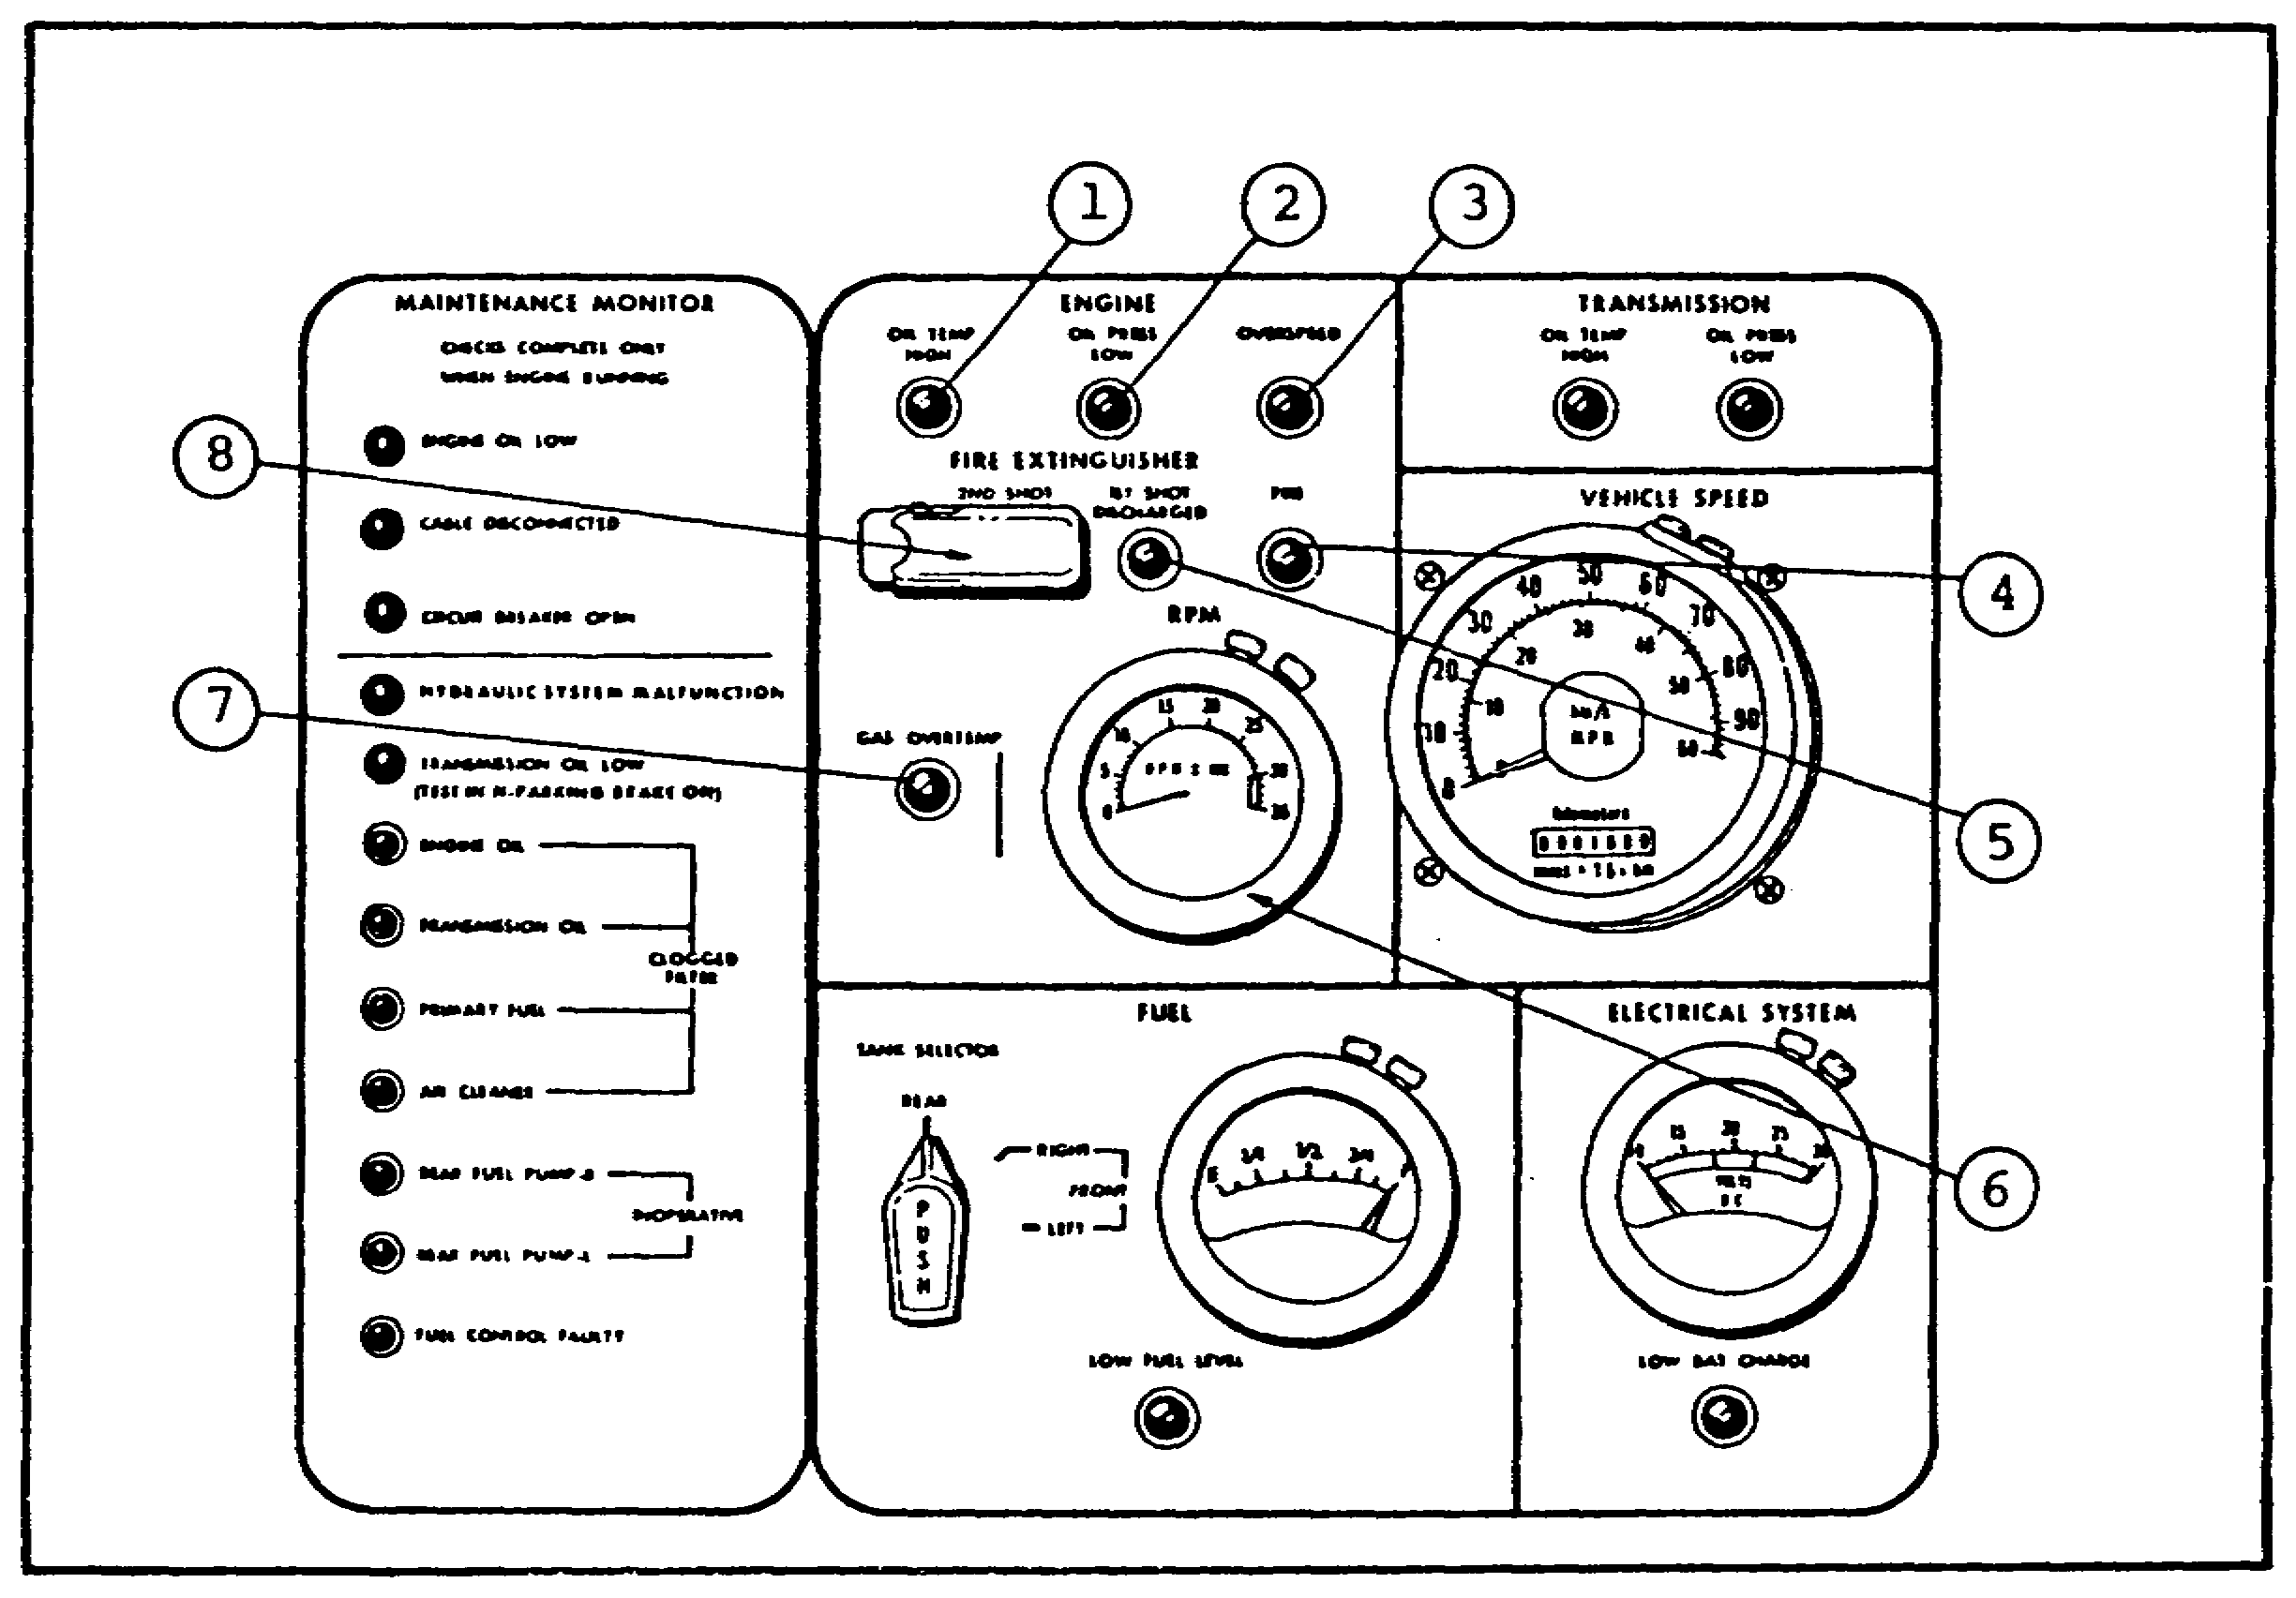

FIGURE 30. DRIVER'S INSTRUMENT PANEL.

49

M1 ENGINE AND COOLING SYSTEM - OD0486 - LESSON 1/TASK 2

5. Conclusion

In the previous two tasks, the components that comprise the AGT 1500 gas turbine engine, principles of operation, a comparison of reciprocating and turbine engines and the auxiliary systems that support, control and monitor the engine were discussed. From these two tasks, it is easy to see why the gas turbine engine is a highly efficient engine that produces greater power, in relation to fuel consumption, than a reciprocating engine of similar dimensions.

50

M1 ENGINE AND COOLING SYSTEM - OD0486 - LESSON 1/PE 1

PRACTICAL EXERCISE 1

1. Instructions

Read the scenario and respond to the requirements that follow the scenario.

2. Scenario

You have been assigned as an instructor in the AGT 1500 C phase at the United States Armor School, Fort Knox, Kentucky.

One of your assignments, after getting settled into the post, is to rewrite the review questions on the "Construction of the AGT 1500 C Turbine Engine, Supporting Systems, Controls, and Monitoring Devices."

After two weeks of hard, diligent work reviewing and rewriting the questions, you finally have them written. All that remains now is to prepare the answer sheet for the questions.

3. Requirement

Below are the questions that you wrote in the scenario above. Using your knowledge of the AGT 1500 C turbine engine and this subcourse, provide an answer sheet for these questions.

a. How does a turbine engine replenish its air supply?

b. What components comprise the basic construction of an axial compressor?

c. The twin-spool compressor incorporates two mechanically independent compressor systems. What are their names?

d. What is the purpose of a turbine nozzle?

e. The air diffuser is a component of which module?

f. Name the four major components externally mounted on the accessory gearbox.

51

M1 ENGINE AND COOLING SYSTEM - OD0486 - LESSON 1/PE 1

g. How many stages of compression are provided in the high pressure compressor?

h. What component directs the gases onto the first power turbine?

i. What component controls air entering the low pressure compressor?

j. What is the purpose of the tachometer?

k. In the lubrication system, if air is introduced into the system, it must be vented. How is air vented from the system?

l. What is the power turbine overspeed point set at?

52

M1 ENGINE AND COOLING SYSTEM - OD0486 - LESSON 1/PE 1

LESSON 1. PRACTICAL EXERCISE - ANSWERS

Requirement

a. The air supply is replenished through the use of the air inlet section, which may be equipped with inlet guide vanes, which serve to direct the air into the first stage of the compressor.

b. The basic components that comprise an axial compressor are the rotor blades and stator vanes.

c. The names of the two mechanically independent compressor systems are the high pressure compressor and the low pressure compressor.

d. The purpose of the turbine nozzle is to discharge the gases onto the blades of the turbine wheel at the proper angle.

e. The air diffuser assembly is a component of the forward module.

f. The following components are externally mounted on the accessory gearbox:

o Gearbox air vent tube

o Hydraulic drive pad

o Oil pump drive pad

o Drain valve and magnetic plug

g. There are four stages of compression in the high pressure compressor.

h. The air diffuser assembly directs the gases onto the first power turbine.

i. The inlet guide vane is the component that controls the air entering the low pressure compressor.

53

M1 ENGINE AND COOLING SYSTEM - OD0486 - LESSON 1/PE 1

j. The tachometer shows the engine speed in hundreds of revolutions per minute (rpm).

k. If air is introduced into the lubrication system it is vented by means of the air/oil centrifugal separator.

l. The power turbine overspeed point is set at 107-109 percent.

54

M1 ENGINE AND COOLING SYSTEM - OD0486 - LESSON 2/TASK 1

LESSON 2

PRINCIPLES OF THE COOLING SYSTEM - M1 TANK

TASK 1. Describe the components and function of the cooling system - M1 tank.

CONDITIONS

Within a self-study environment and given the subcourse text, without assistance.

STANDARDS

Within 1 hour

REFERENCES

No supplementary references are needed for this task.

1. Introduction

All internal combustion engines (which includes the AGT 1500) are equipped with some type of cooling system because of the high temperatures they generate during operation. The AGT 1500C, however, reaches its highest temperature just after the engine has been stopped. High temperatures are necessary to generate the high gas pressures. Power cannot be produced efficiently without high temperatures. However, it is not possible to use all of the heat of combustion without harmful results. The temperature in the combustion chamber during the burning of the fuel is well above the melting point of iron. Therefore, if nothing is done to cool the engine during operation, the valves will burn and warp, the lubricating oil will break down and the bearings and pistons will overheat causing engine seizure.

In lesson one, the construction, theory of operation, support systems, controls, and monitoring devices for the AGT 1500 gas turbine engine were covered. In this lesson the components and function of the cooling system will be covered.

55

M1 ENGINE AND COOLING SYSTEM - OD0486 - LESSON 2/TASK 1

2. Cooling System Function

The engine and transmission oil cooling systems maintain the oil temperatures within acceptable limits under all climactic extremes and operating conditions. The cooling system is designed to provide adequate cooling at a tractive effort of 0.70 gross vehicle weight with the ambient air temperature at 125 degrees fahrenheit. The primary cooling system consists of the fan, fan drive system, cooling duct, transmission oil cooler, and the engine oil cooler. The auxiliary cooling system consists of the fan, fan drive system, cooling duct, and the auxiliary transmission oil cooler.

The fans operate at 1.73 times the engine output speed, except during deep water fording when they are disengaged. The auxiliary cooling fan is also disengaged when additional transmission cooling is not required. The two-stage cooling fans are used to obtain the required static air pressure rise and airflow at low fan speeds, and to reduce fan noise.

The coolers are six inches thick and fin spacing is varied to balance the airflow and to maximize the system heat rejection. The engine cooler fin spacing is 18 fins per inch and the primary transmission cooler, which is mounted adjacent to the engine cooler, has a fin spacing of 15 fins per inch. The denser engine cooler core is located directly behind the fan, to obtain the high cooler effectiveness, which is required for engine oil cooling. The primary transmission cooler core airflow is partially obstructed by the transmission. The primary transmission cooler core density and the transmission obstruction result in an airflow restriction equivalent to the engine cooler and, therefore, balance the flow between the two coolers. The auxiliary transmission cooler has 11 fins per inch. This cooler is smaller than the combined area of the engine and the primary transmission oil coolers; resulting in a higher cooler airflow face velocity. The cooler fin spacing is opened to reduce the static pressure drop through the cooler, and to optimize the system capability.

The fan drive clutch is an electromagnetic clutch, mounted inside the fan input housing. The clutch friction surfaces operate dry and directly engage an adapter on the fan blades. The bearings in

56

M1 ENGINE AND COOLING SYSTEM - OD0486 - LESSON 2/TASK 1

the clutch are sealed and are used to support the fan drive output and gear shaft. This arrangement allows the clutch to be incorporated in the fan drive without significantly increasing the distance between the fan and the fan drive shaft, thereby reducing the overall length of the cooling system. The fan drives, gears and bearings are continuously cooled and lubricated with transmission oil. Although the primary cooling system will cool the transmission at high speeds, in 125 degrees fahrenheit 'ambient temperatures, the auxiliary cooling fan has an electrically controlled clutch and operates when the transmission oil temperature reaches approximately 265 degrees fahrenheit. The auxiliary fan ceases operation when the oil temperature drops below 230 degrees fahrenheit.

3. Cooling System Characteristics

a. Engine Oil Cooler. The engine oil cooler has an inlet oil temperature of 325 degrees fahrenheit, with a heat rejection of 4,775 British thermal units (BTU) per minute. The engine oil cooler allows for an oil pressure drop of 10 psi, and an air pressure drop of 4.3 inches of water. The oil flows through the engine oil cooler at a rate of 66.7 pounds per minute, with an airflow rate of 177 pounds per minute. The engine oil cooler has a hydrostatic pressure of 400 psi and weighs approximately 59 pounds. The oil type of the engine oil cooler is MIL-L-23699 or MIL-L-7808.

b. Primary Transmission Oil Cooler. The primary transmission oil cooler weighs 65 pounds and has a hydrostatic pressure of 600 psi. The primary transmission oil cooler uses type MIL-L-2104C oil. The primary transmission oil cooler has an oil flow rate of 460 pounds per minute, and an airflow rate of 213 pounds per minute. The primary transmission oil cooler allows for an oil pressure drop of 10 psi, and an air pressure drop of 3.3 inches of water. The heat rejection for the primary transmission oil cooler is 6,252 BTU per minute. The primary transmission oil cooler has an inlet oil temperature of 310 degrees fahrenheit and inlet air temperature of 145 degrees fahrenheit.

c. Auxiliary Transmission Oil Cooler. The auxiliary transmission oil cooler has an inlet oil temperature of 265 degrees fahrenheit, and an inlet

57

M1 ENGINE AND COOLING SYSTEM - OD0486 - LESSON 2/TASK 1

air temperature of 145 degrees fahrenheit. The heat rejection rate for the auxiliary transmission oil cooler is 7,758 BTU per minute. The auxiliary transmission oil cooler has an allowable oil pressure drop of 15 psi, and an allowable air pressure drop of 4.1 inches of water. The oil flow rate for the auxiliary transmission oil cooler is 460 pounds per minute with an airflow rate of 385 pounds per minute. Like the primary transmission oil cooler, the auxiliary transmission oil cooler uses MIL-L-2104C type oil. The hydrostatic pressure of the auxiliary transmission oil cooler is 600 psi, with a weight of 73 pounds.

d. Cooling Fan. The cooling fan is a dual stage vane axial type, with a maximum input speed of 5,300 rpm and a design point fan speed of 3,700 rpm. The power required to turn the fan at the design point fan speed is 21 horsepower. The fan has an airflow rate of 7,500 cubic feet per minute. There are two fans per vehicle, each unit weighing approximately 90 pounds. The cooling fan is driven by the left front power takeoff on the transmission.

e. Fan Clutch. The fan clutch is an electromagnetic type with a minimum input speed of 5,300 rpm. The dynamic torque, at a minimum ambient temperature of 145 degrees fahrenheit, is 100 to 150 foot pounds, with a minimum static torque of 150 foot pounds. The clutch has a disengagement voltage of 18 to 33 volts direct current. The fan clutch weighs 50 pounds.

4. Conclusion

In the first paragraph of the introduction, you learned why it is important that the engine be cooled. From this task one could draw the conclusion that the engine cooling system is just as important a support system to the engine as the fuel or air system. All the support systems work together to maintain the M1 Abrams tank engine at the proper operating level.

58

M1 ENGINE AND COOLING SYSTEM - OD0486 - LESSON 2/PE 2

PRACTICAL EXERCISE 2

1. Instructions

Read the scenario and respond to the requirements that follow the scenario.

2. Scenario

You have finished revising the questions on the construction of the AGT 1500 C turbine engine, supporting systems, controls, and monitoring devices. The other instructors at the school were so impressed with your work that they have assigned you to perform the same task on the review questions for the cooling system.

You have reviewed the existing questions and made all the necessary changes. All that is left now is to make up a revised answer sheet for the questions.

3. Requirement

Below are the review questions that you made up. Using your knowledge of the M1 cooling system, and this subcourse, provide an answer sheet for these questions.

a. What is the engine cooler fin spacing?

b. Describe the fan drive clutch.

c. What type of oil is used in the engine oil cooler?

d. The primary transmission oil cooler has an inlet air temperature of what degrees fahrenheit?

e. What is the maximum input speed of the cooling fan?

f. What is the disengagement voltage of the fan clutch?

59

M1 ENGINE AND COOLING SYSTEM - OD0486 - LESSON 2/PE 2

LESSON 2. PRACTICAL EXERCISE - ANSWERS

Requirement

a. The engine cooler fin spacing is 18 fins per inch.

b. The fan drive clutch is a spring-engaged electric clutch that mounts inside the fan input housing. The friction surfaces operate dry and directly engage an adapter on the fan blades.

c. The engine oil cooler uses either MIL-L-23699 or MIL-L-7808.

d. The inlet air temperature of the primary transmission oil cooler is 145 degrees farenheit.

e. The maximum input speed for the cooling fan is 5,300 rpm.

f. The disengagement voltage for the fan clutch is 18 to 33 volts direct current.

60

